 | 
PANEL ASSESSMENT FINAL REPORT
HUNTER AND CENTRAL COAST REGIONAL PLANNING PANEL

PANEL REFERENCE & DA NUMBER | PPSHCC-91 – Central Coast  DA/1260/2021 (PAN -144003)
PROPOSAL | Seniors Housing Development comprising 89 dwellings, in two buildings, strata subdivision and associated demolition, landscaping and other works.
ADDRESS | 24-26 Gallipoli Road, Long Jetty Lot 4 DP 271196  and 315 The Entrance Road Long Jetty (club) Lot 3 DP.2791196
APPLICANT | Frank Mangione & Tim Shelley
OWNER | Tuggerah Lakes Memorial Club Ltd
DA LODGEMENT DATE | 17 September 2021
APPLICATION TYPE | Development Application with a Capital Investment Value > $30 million
REGIONALLY SIGNIFICANT CRITERIA | Clause 2, Schedule 7 of State Environmental Planning Policy (State and Regional Development) 2011
CIV | $32,931,677.00 (excluding GST)
CLAUSE 4.6 REQUESTS | No
LIST OF ALL RELEVANT PLANNING CONTROLS (S4.15(1)(A) OF EP&A ACT) | - State Environmental Planning Policy (SEPP) (Resilience and Hazards) 2021  - SEPP (Industry and Employment) 2021  - SEPP (Transport and Infrastructure) 2021  - SEPP (Planning Systems) 2021  - SEPP No.65 - Design Quality of Residential Apartment Development  - SEPP (Building Sustainability Index: BASIX)  - SEPP (Housing for Seniors or People with a Disability) 2004  - SEPP (Housing) 2021  - Wyong Local Environmental Plan 2013  - Central Coast Local Environmental Plan 2022  - Draft Remediation of Land SEPP  - Draft Design and Place SEPP  - Draft SEPP (Environment)
TOTAL & UNIQUE SUBMISSIONS | Nil
KEY ISSUES | ADG compliance; application of SEPP 65 and SEPP-HSPD; Legibility and wayfinding; Boundary interface with the adjoining car park; Physical link to club; Management of club impacts; Engineering matters; Noise impacts; Waste servicing; Social impacts; Internal Solar access
DOCUMENTS SUBMITTED FOR CONSIDERATION | Plans and information available on the portal
PLAN VERSION | 7 June 2022 -Version 2-4
PREPARED BY | Principal Development Planner - Salli Pendergast
DATE OF REPORT | 7 September 2022

- THE SITE AND LOCALITY

  - The Site

The subject site is one of four community lots that is a large irregularly shaped corner lot with a road frontage on three sides extending between the western side of The Entrance Road (Central Coast Highway), the eastern side of Gallipoli Road, and the northern side of Archbold Road. The broader site (including community Lots 2 and 4) accommodates an existing registered club known as ‘Diggers at The Entrance’ and a multi-level hotel building.

The subject site area comprising Lot 4 is 7,144m² in area and is occupied by two dwellings and an at-grade car park (102 spaces) for the Club. Lot 4 has a frontage to The Entrance Road to the east of 89.23m, a frontage to Archbold Road to the south of 69.905m, and a frontage to Gallipoli Road to the west of 80.535m. The site has a cross fall of 8.75m from the lowest point on the south-west corner to the highest point on the north-east corner.

Two single-storey weatherboard cottages are currently located on the two former residential properties on the western side of the site fronting Gallipoli Road. The eastern half of the site is occupied by the southern section of the main carpark for the Diggers Club and comprises an asphalt surface and 102 line-marked car parking spaces. Surrounding the site on all sides is predominantly residential development including both single dwellings and medium density residential development. There are also varied commercial activities along The Entrance Road in the vicinity of the site. Tuggerah Lake is 170m to the west of the site and there are views from the site across to the lake.

There are scattered trees (approximately 42) along the site frontage (on the adjoining former residential lots) and around the perimeter of the carpark, otherwise, vegetation on the site is minimal. The site is not identified as bushfire prone, or flood affected land. The site slopes from where the club is situated down towards Archbold Street.

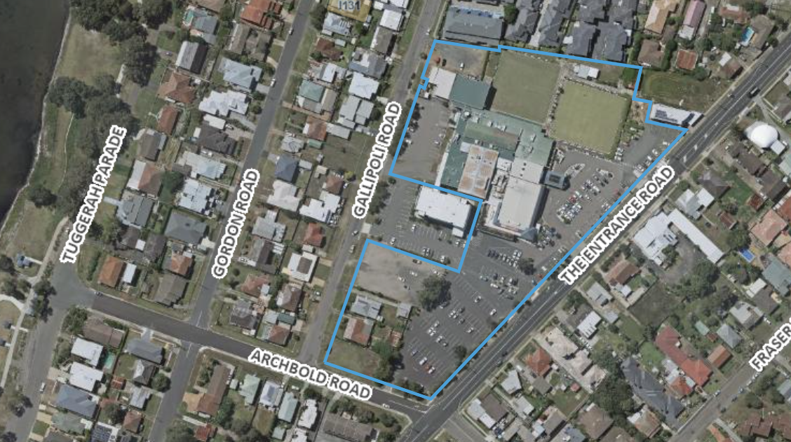
Above: Aerial view of site

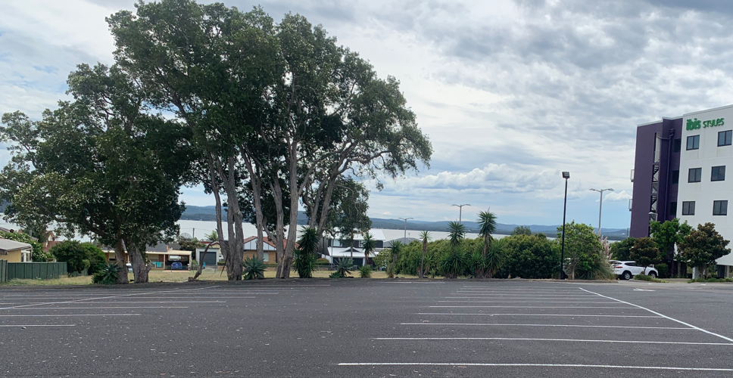
Above: Photo of site looking west across to the lake.
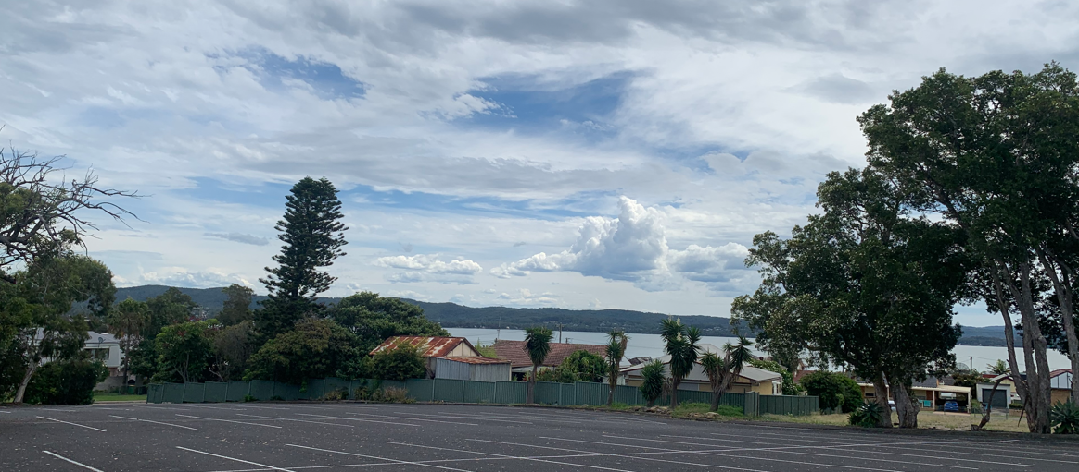
Above: Photo of site looking south west across to the lake.

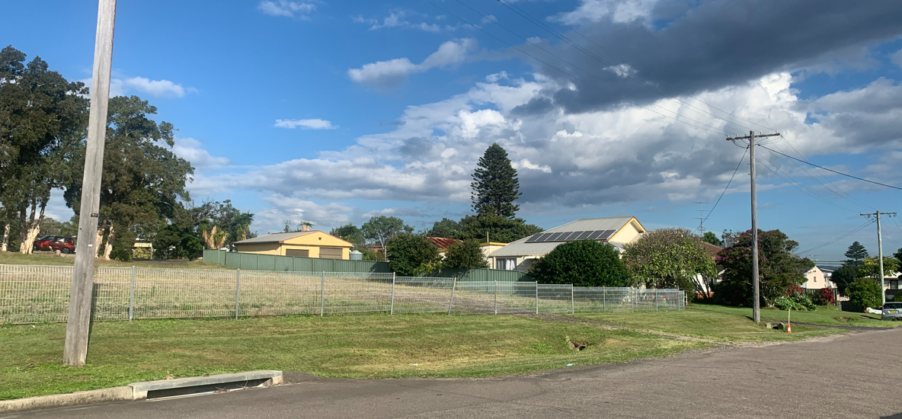
Above: Photo of site along Gallipoli Road frontage (looking south east)

  - The Locality

The site is located approximately 750 metres south of The Entrance Town Centre and 600m north of the Long Jetty local centre. To the west of the site (170m) is Tuggerah Lake and to the east (1.2km) are various beaches including The Entrance, Blue Bay and Toowoon Bay. The Entrance Road, also known as the Central Coast Highway, is the main road extending north- south on the eastern part of the lake. Regular bus services travel along The Central Coast Highway.

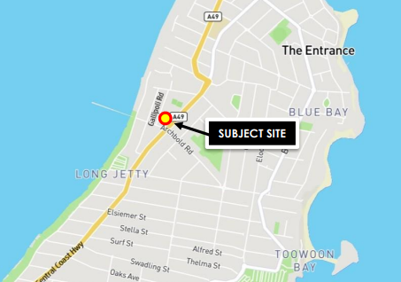
The site is located within an established and well serviced area with various retail and commercial businesses in the surrounding area. The immediately surrounding development comprises one and two storey scale, low to medium density residential to the north, west and south and scattered residential and commercial along The Entrance Road.

- THE PROPOSAL AND BACKGROUND

  - The Proposal

The proposal seeks consent for the demolition of all structures on lot 4 (the subject site); construction of a seniors housing development in two buildings containing 89 independent living apartments and associated facilities and ancillary works including landscaping and boundary fencing; and the strata subdivision of the site into 89 strata-titled allotments plus common property.

Specifically, the proposal involves:

- Demolition of all structures, removal of the existing car park on lot 4 and tree removal.

- Undertaking of civil works across the site comprising excavation, cut and fill and other bulk earthworks as necessary, as well as the construction of the basement, retaining walls, access driveway into the site off Gallipoli Road and on-site detention (OSD) tank/bio-retention basin.

- Construction of two buildings (eastern and western) ranging in size between 2-5 storeys containing:

  - 89 independent living units and associated facilities (100% of which are adaptable) with the following bedroom mix:
    - 87 x two-bedroom apartments; and
    - 2 x three-bedroom apartments.
  - ground floor meeting room, staff room sales office and reception.
  - ground floor parcel store and mail room.
  - communal open space area on level 2 of western building comprising outdoor kitchen, Barbeque, and community garden.
  - private rooftop garden above Unit 54 on level 4 of the western building; and
  - communal open space on level 5 of the eastern building comprising landscaped courtyard.
  - parking for 106 vehicles in single basement carparking level constructed across a partly excavated ground floor.

- The construction (within the site) of a footpath and associated pedestrian crossing from the boundary of Lot 4 (in the north-east corner) into and across the existing carpark in Lot 3 to provide access and physical connectivity between the existing club (i.e. club facilities) and the proposed development.

- Provision of all necessary utility services.

- Construction of all boundary fencing.

- Comprehensive landscaping of the site including all tree and shrub planting and the construction of pathways, stairs, gates, planter boxes, retaining walls, seating, and barbeques at various locations within the site.

- Strata Subdivision of the development into 89 strata title allotments plus common property.

The carpark is to be accessed from a single driveway on Gallipoli Road. The buildings are to be constructed in a combination of sandstone, face brick, rendered brick and metal-cladded external walls and planter boxes, with horizontal timber batten privacy and shade screens, metal balcony balustrades, aluminium windows and doors, and a flat steel roof with timber-clad soffits and steel fascia’s, gutters, and downpipes.

The two proposed buildings (eastern and western) have been designed to follow the topography of the site, stepping from the northern boundary at the interface with the Club and Hotel lots down to Archbold Road to maintain compliance with the applicable height limits.

The western building is serviced via two single lift wells at the northern and southern ends of the carpark which provide access to all four residential levels above and the communal open space and kitchen/BBQ area on Level 2. An additional lift is located to the immediate east of the ground floor office and reception area providing access to the central spine of open space and pathway through the site at Level 1.

The eastern building is serviced via two double lift wells at the northern and southern ends of the carpark which provide access to all five residential levels above and the smaller area of communal open space in the south-eastern corner of Level 5.

A Facility Manager will be employed to oversee the day-to-day operation of the development and address any concerns by residents. The Facility Manager would be located on site as necessary and will be available on call 24 hours-a-day, 7 days-a-week.

The key development data is provided in Table 1.

Table 1: Key Development Data
Control | Proposal
Site area | Lot 4 (24 Gallipoli St) – 7,143m²  Lot 3 (315 The Entrance Rd) – 16,740m²  Total - 21,873m²
Gross Floor Area (GFA) | 8495m² proposed (Lot 4)  Existing club (Lot 3) GFA 8060m²  Existing hotel (Lot 2) GFA 1999m²  Substation (Lot 1) – no FSR
Floor Space Ration (FSR) (residential) | There are two FSR’s applying to the development (refer map in the WLEP section below)  0.49:1 (GFA 992m²) is proposed, and a max permitted of 0.5:1 (has an area of 2,011m²)  0.72:1 (proposed GFA Seniors is 7,503m² and existing GFA Club of 8060m² which totals a GFA of 15,734m²) and a max permitted of 0.85:1 (has an area of 21,873m²)  The applicant has advised of compliance with both applicable FSR controls across the site (being combined Lot 3 and 4).  It is noted that were the FSR to be assessed for Lot 4 alone (ie. without inclusion of the Lot 3 club site), the proposed GFA of 8666m² on a site area of 7143m² would result in an FSR of 1.2:1 which would exceed the LEP control. However, Lots 3 and 4 have a legally bound relationship with each other.  Additionally, the applicant has carried out the exercise of calculating the FSR for Lot 2 (the hotel) as part of the site area and demonstrated that the existing (hotel) FSR on Lot 2 separately, and in combination with the other lots, complies with the maximum FSR of 0.85:1.  This exercise was carried out because the hotel on Lot 2 was developed prior to community title subdivision of the site, and as such, the existing approved GFA for the hotel on Lot 2 was originally calculated based on a site area that included the Club site (lot 3) as well as a portion of Lot 4.
Clause 4.6 Requests | No
No of apartments | 89 Independent Living Units  The units comprise:  - 87 x two bedroom  - 2 x three bedroom
Max Height | 8.5m  16m  The plans show that the proposed development, at its highest point in each mapped building height zone, does not exceed either of the two maximum height limits applicable to the site.  There are two height limit controls applying to the development (refer map in the WLEP section below)
Landscaped area  Soft Landscaped area | 3,763m² (52% site area)  37% (2660m²)
Deep Soil | 1,306m² (18% site area)
Communal Open Space | 2,030m² (28% site area)
Car Parking spaces | 106 Spaces  - 90 allocated  - 16 visitors  - 3 motorcycle spaces  - 3.2m minimum width spaces
Loading | Waste vehicle loading bay 11m HRV
Setbacks | Frontages all levels: 7.5m  Side/Rear (northern): 6m (all storeys)  Complies except that the 5th storey side/rear setback under the DCP requires 9m setback but only 6m proposed. The applicant has argued that the ground level of this part of the building is below the ground level so that there are only 4 levels of the building above ground level.
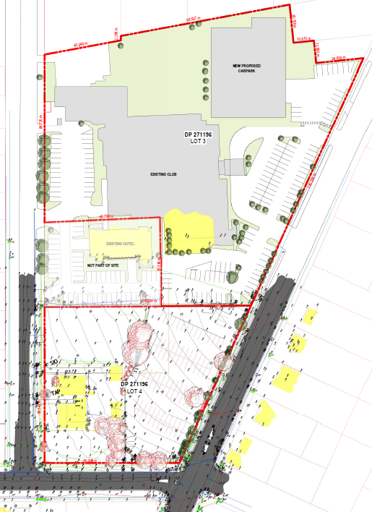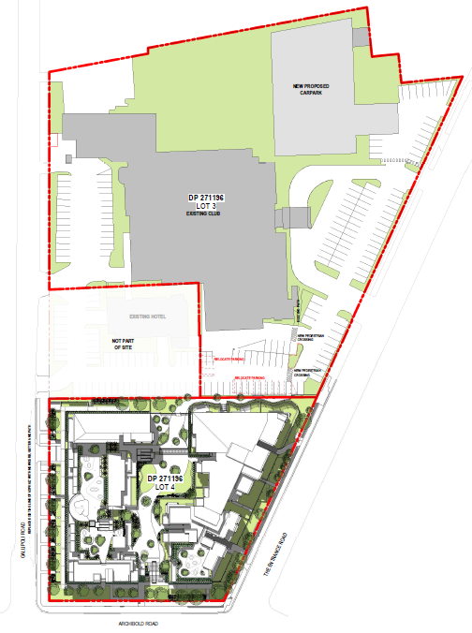
Above left: Existing site and above right: Proposed development
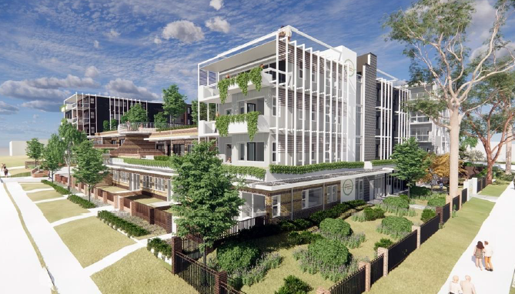
Above: Applicant’s 3-D render of the proposal viewed from Gallipoli and Archbold Roads

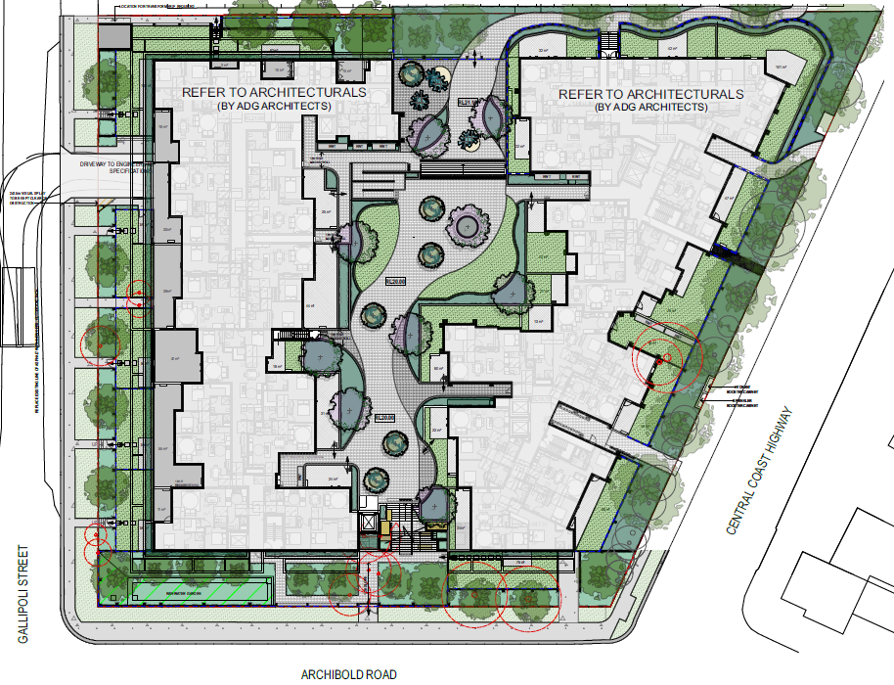
Above: Landscape Masterplan for site
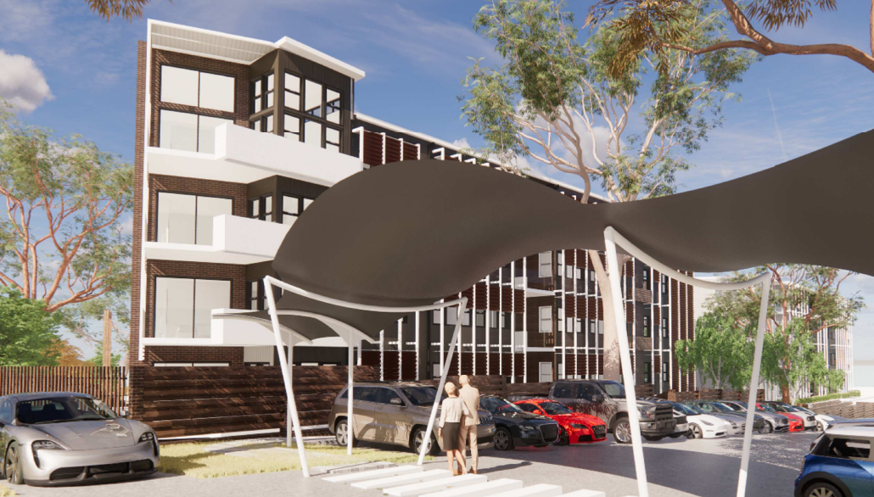
Above: Depiction of the pedestrian link to the club
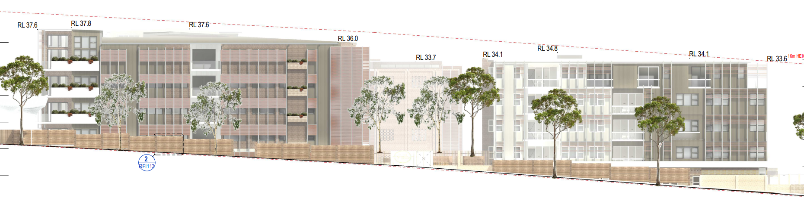
Above: Northern Building Elevations
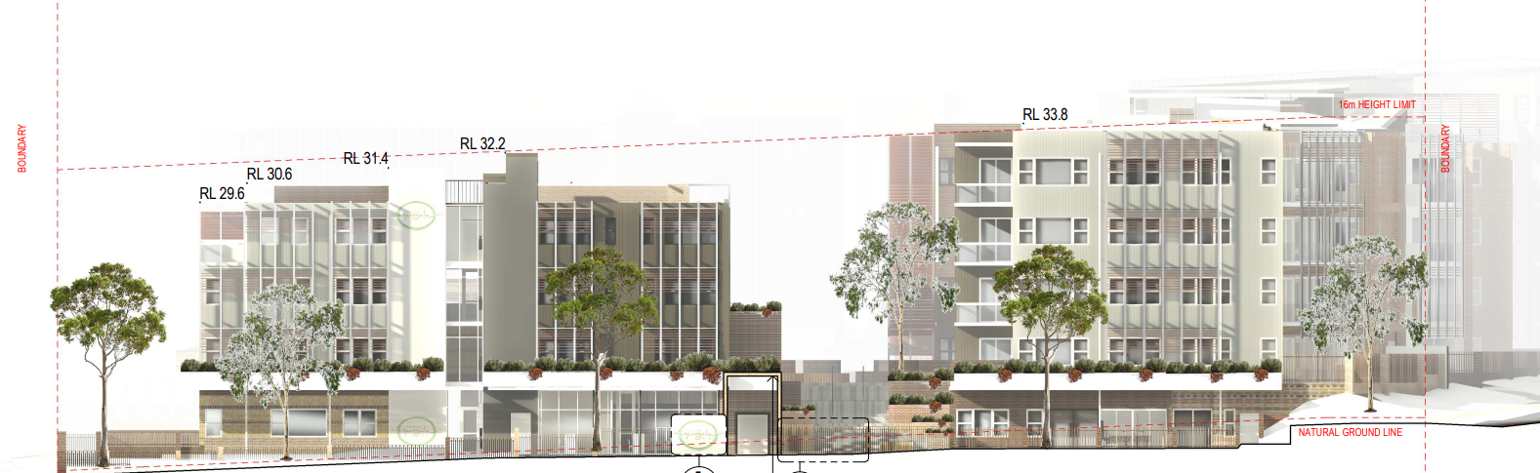
Above: Southern Building Elevations

  - Background

The development application was lodged on 17 September 2021. A chronology of the development application since lodgement is outlined in Table 2.

Table 2: Chronology of the DA
Date | Event
1 October 2021 | Exhibition of the application
27 September 2021 | DA referred to external agencies
28 October 2021 | Kick off Briefing HCCRPP
28 February 2022 | Request for Information from Council to applicant
3 March 2022 | Panel briefing
13 May 2022 -4 July 2022 | Amended plans and information provided
7 September 2022 | Panel Determination

  - Site History

- A pre-lodgement meeting (PL/86/2021) was held on 26 April 2021 for the proposed construction of a five storey seniors living development associated with Diggers at The Entrance RSL Club comprising of 89 units, public open space and basement carpark.

- A pre-lodgement meeting PL/291/2020 was held on 24 November 2020, for the proposed construction of a five storey seniors living development associated with Diggers at The Entrance RSL Club comprising of 90 independent living units, public open space and basement carpark.

- Development Consent No. DA/1196/2021 was granted on 21 July 2022 for the construction of a 2 level car park in the north eastern corner of Lot 3 to service the club. This consent will compensate for the removal of parking spaces for the current DA by creating 107 parking spaces. The development of Lot 4 for the proposed seniors housing development will result in the loss of 102 existing parking spaces. With the removal of a bowling green for the 2 storey carpark, the proposal will result in an increase of 13 spaces on site for the club.

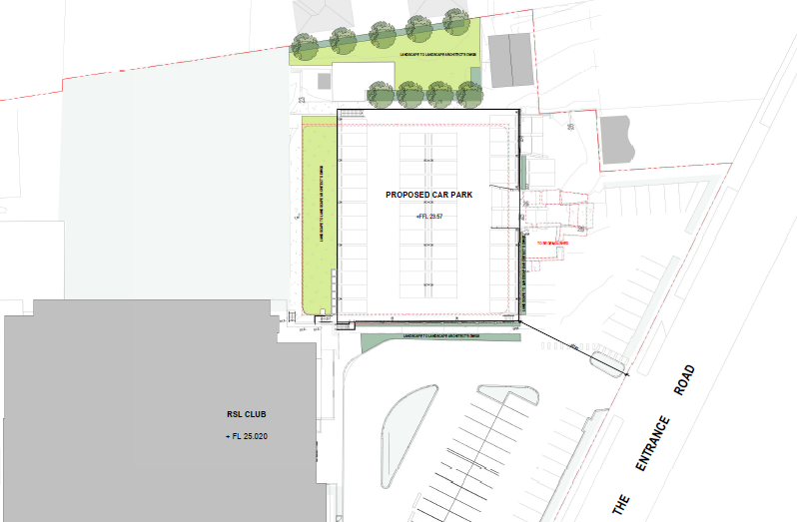
Above: The plan for the 2 level carpark approved under DA/1196/2021

- Development Consent No. DA/197/2018 was granted on 17 April 2018 for a four lot community title subdivision of the site.

Lot 1 | 17.49m² | community property containing an electricity easement and kiosk/substation
Lot 2 | 2,679m² | development lot containing the Ibis Hotel
Lot 3 | 1.674 hectares | development lot containing the main Diggers Club, the bowling greens and surrounding land and the northern half of the front Club carpark
Lot 4 | 7,143m² | development lot containing two dwellings fronting Gallipoli Road and the southern half of the front Club carpark

Condition 8.6 of the consent reads:
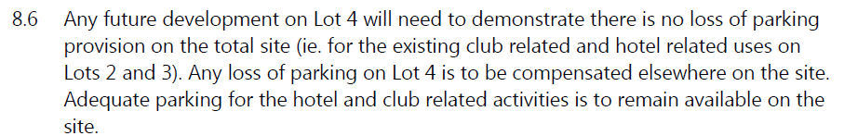
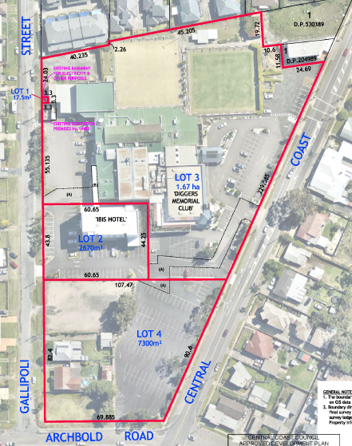
Above: Approved plan for the community title subdivision of the site

- Development Consent No. DA/14/2013 was granted on 27 June 2013 for a motel comprising 56 rooms associated with the existing registered club (Diggers@ The Entrance Club) at 315 The Entrance Road, Long Jetty. The consent was amended on three occasions and the latest modified consent is DA/14/2013/C.

The proposed hotel floor area was approximately 1999m². The FSR calculation for the hotel was based on a total site area of 25,345m² which included the existing club site at 315 The Entrance Road (including the at grade car park but excluding the then residential sites with the dwelling houses fronting Gallipoli). This development is now contained within Lot 2 of the Community Scheme (DP.271196) and is known as 18 Gallipoli Road. Lot 2 does not form part of the site area for the development.

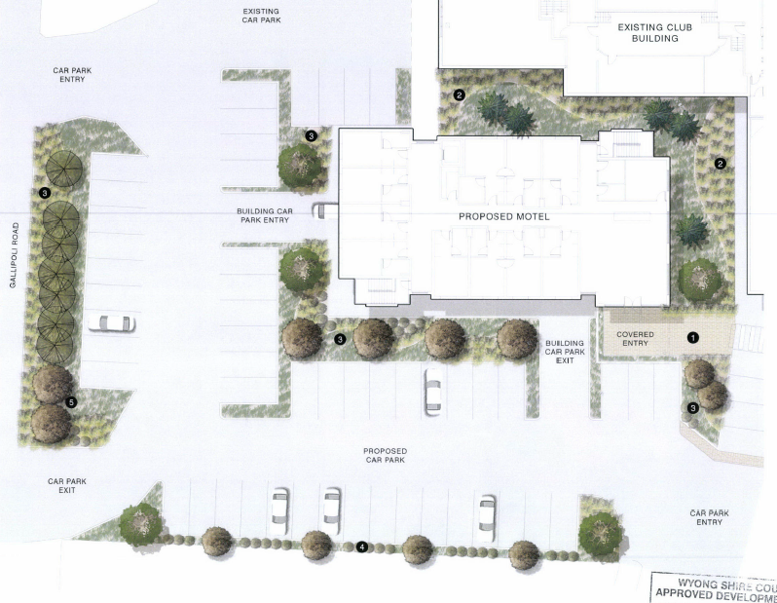
Above: Stamped approved Consent plans for DA/14/2013 -Ibis Hotel

- Development Consent No. DA/871/2008 for alterations and additions (Tuggerah Lakes Memorial Club) was granted on 10 September 2008.

- Development Consent No. DA/996/2006 for alterations and additions to the club was granted on 25 July 2006.

- Development Consent No. DA/617/90 for alterations and additions to club including rearrangement of car parking areas and proposed multi-level car park (was granted on 3 December 1990.

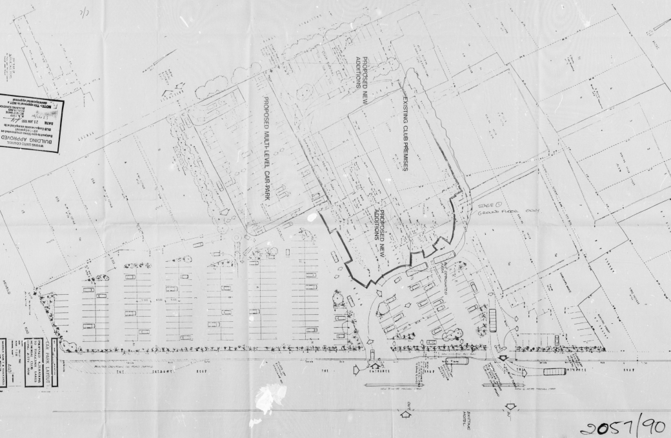
Above: Approved plan under DA/617/90

- STATUTORY CONSIDERATIONS

When determining a development application, the consent authority must take into consideration the matters outlined in Section 4.15(1) of the Environmental Planning and Assessment Act 1979 (‘EP&A Act’). These matters as are of relevance to the development application include the following:

- the provisions of any environmental planning instrument, proposed instrument, development control plan, planning agreement and the regulations
- the likely impacts of that development, including environmental impacts on both the natural and built environments, and social and economic impacts in the locality,
- the suitability of the site for the development,
- any submissions made in accordance with this Act or the regulations,
- the public interest.

These matters are further considered below.

It is noted that the proposal is not considered to be:

- Integrated Development (s4.46)
- Designated Development (s4.10)
- Requiring concurrence (s4.13)
- Crown DA (s4.33)

  - Section 4.15(1)(a)(i) - Provisions of Environmental Planning Instruments

The following Environmental Planning Instruments are relevant to this application:

- State Environmental Planning Policy (SEPP) (Resilience and Hazards) 2021
- SEPP (Industry and Employment) 2021
- SEPP (Transport and Infrastructure) 2021
- SEPP (Planning Systems) 2021
- SEPP No.65 - Design Quality of Residential Apartment Development
- SEPP (Building Sustainability Index: BASIX)
- SEPP (Housing for Seniors or People with a Disability) 2004
- SEPP (Housing) 2021
- Central Coast Local Environmental Plan 2022
- Wyong Local Environmental Plan 2013
- Draft Remediation of Land SEPP;
- Draft Design and Place SEPP;
- Draft SEPP (Environment);

A summary of the key matters for consideration and non-compliances arising from the relevant EPIs and DCP’s are outlined in Table 3. The pre-conditions to the grant of consent have been considered and are outlined in bold.

Table 3: Summary of Key Matters in the Relevant EPIs
EPI | Matters for Consideration | Comply (Y/N)
SEPP (Planning Systems) 2021. | - Section 2.19 declares the proposal as regionally significant development pursuant to Clause 2 (General Development over $30 million) of Schedule 6 of the SEPP (Planning Systems) 2021. | Y
SEPP 65- Design Quality of Residential Apartment Development | - Clause 30(2) - Design Quality Principles.  In this regard, the applicant has advised:  SEPP 65 is not applicable to the proposed development. This is indicated under Clause 4 of SEPP as follows:  “SEPP 65 and the ADG applies to residential flat buildings, shop top housing and the residential component of mixed-use developments”  There is no reference to “seniors housing”, which is separately defined from residential flat buildings under the Standard Instrument and also under Wyong LEP 2013.  Legal advice was provided by the applicant to support their position.  Legal advice was obtained by Council in relation to the advice provided by the applicant which confirmed that the provisions of SEPP 65 apply to the proposal.  Notwithstanding the above, the proposal was amended to demonstrate compliance with the provisions of the SEPP. | Y
SEPP (Resilience and Hazards) | - Chapter 3 (Remediation of Land) - Potential contamination and remediation has been considered in the assessment of the proposal. A Preliminary Site Investigation and Detailed Site Investigation have been submitted. These have been reviewed by Council’s relevant officer who has advised that the proposal is satisfactory subject to conditions.  - Chapter 2 (Coastal Management) - The site is located within both the Coastal Use Area and Coastal Environment Area. The proposal is consistent with Sections 2.10 and 2.11 of the SEPP. | Y
SEPP (Transport and Infrastructure) 2021 | The following sections are relevant:  Section 2.119 - Development with frontage to classified road  Section 2.120 - Impact of road noise or vibration on non-road development  Section - Traffic-generating development  The DA was referred to TFNSW for comment. The proposed development will have direct pedestrian access to The Entrance Road, a classified State road. The proposed new development is of a size and capacity listed in schedule 3, column 3 of the TISEPP, and is therefore a traffic generating development from an active transport perspective. TfNSW recommends that consideration be given to the following measures to enhance safety and accessibility for pedestrians and cyclists. | Y
Seniors Housing SEPP | The SEE states that the DA has not been lodged under SEPP (Housing for Seniors or People with a Disability) 2004, however, that the proposal complies with the SEPP. | Y
SEPP (Housing) 2021 | This SEPP commenced on 26 Nov 2021.The DA was lodged prior to the commencement of this SEPP and the savings provisions apply. | Y
SEPP (Industry and Employment) 2021 | - Chapter 3 (Advertising and Signage) – The proposed new identification signage has been assessed as ‘business identification signs’ with regard to Section 3.6 of the SEPP. The proposed signage is considered consistent with the objectives of the policy (under Section 3.1(1)(a)) and the assessment criteria specified under Schedule 5 (Assessment criteria) of the instrument. | Y
BASIX SEPP | Basix Certificate 1195594M has been provided for the development. No compliance issues identified subject to imposition of conditions on any consent granted. | Y
CCLEP 2022 | CCLEP 2022 commenced 1 August 202. The savings provisions apply to this DA which was lodged prior to the commencement of CCLEP. Under CCLEP 2022, the site retains its RE1 Public Recreation zoning and Registered Club remains permissible. | Y
WLEP 2013 | Clause 2.3- Zone Objectives and Land Use Table  Clause 2.5 of WLEP and Schedule 1 (Additional Permitted Uses)  Clause 2.6 – Subdivision – Consent Requirements  Clause Minimum Subdivision Lot Size  Clause 4.3 -Height  Clause 4.4 -FSR  Clause 7.1 - Acid Sulphate Soils  Clause 7.9 - Essential Services | Y
Draft EPIs | Draft SEPP (Remediation) 2018. No compliance issues identified. | Y
WDCP | - Chapter 2.4 – Multiple Dwelling Residential Development  - Chapter 2.1 – Parking and Access  - Chapter 2.6 – Signage  - Chapter 3.1 – Site Waste Management  - Chapter 5.3 – The Entrance Peninsula | Y
CCDCP 2022 | The application predates the operation of CCDCP 2022 and therefore Wyong DCP 2013 applies. There is no significant change in relevant DCP controls for parking or other matters under CCDCP 2022. | Y

State Environmental Planning Policy (Planning Systems) 2021

State Environmental Planning Policy (Planning Systems) 2021 applies to the proposal as it identifies if development is regionally significant development. In this case, pursuant to Section 2.19, the proposal is a regionally significant development as it satisfies the criteria in Section 2 (General Development over $30 million) of Schedule 6. The proposal is development with a CIV of $32,931,677.00 (excluding GST). Accordingly, the Hunter and Central Coast Regional Planning Panel is the consent authority for the application.
State Environmental Planning Policy (Resilience and Hazards) 2021

- Chapter 4 – Remediation of Land

The provisions of State Environmental Planning Policy (Resilience and Hazards) 2021 (SEPP RH) Chapter 3 (Remediation of Land) have been considered in the assessment of the development application.

Section 4.6 of SEPP RH requires consent authorities to consider whether the land is contaminated, and if the land is contaminated, it is satisfied that the land is suitable in its contaminated state (or will be suitable, after remediation) for the purpose for which the development is proposed to be carried out.
JK Environments undertook a Preliminary (Stage 1) Site Investigation (PSI), comprising a review of site history information, a walkover site inspection and soil sampling from four of five boreholes drilled for a geotechnical investigation, which concluded that the following potential contamination sources were identified:
• Fill material across the site.
• Commercial use in the south-east section of site. Small quantities of fuels, oils and solvents may have been stored in this area during site use. The storage and potential use of chemicals would have occurred within the former buildings.
• Use of pesticides beneath the buildings and/or around the site.
• Hazardous building materials may be present because of former building and demolition activities. Many areas at the site have been subject to demolition works. These materials may also be present in the existing buildings/ structures on site; and
• an off-site dry cleaner was located cross-gradient of the site in 1961 (70m to the south-east) and is a potential source of contamination.
The report concluded that the site can be made suitable for the proposed development provided the following recommendations are implemented:
1. A Detailed Site Investigation should be undertaken to address the data gaps and potential contamination risks identified at the site.
2. A hazardous materials assessment should be undertaken of the existing buildings at the site prior to demolition works.
3. An Asbestos Management Plan (AMP) should be prepared for the proposed development works; and
4. if required, a Remediation Action Plan (RAP) should be prepared to outline measures to reduce the risks associated with contamination.

In response to recommendation 1, AssetGeoEnviro/Reditus Consulting conducted a Stage 2 Detailed Site Investigation (DSI) which in summary, found that the site is suitable for the proposed development (as residential apartments with minimal access to soils and one level of underground car parking) and that no further contaminated land site assessment or remediation is required. Whilst the site is considered suitable for the proposed development, AssetGeoEnviro/Reditus Consulting also provided further recommendations under section 13.2 of the DSI.
Council’s Senior Environmental Protection Officer has reviewed the reports and has advised:

Consideration has been given to the contamination report that was prepared on behalf of the applicant.

The proponent has addressed the requirements under State Environmental Planning Policy 55 “Remediation of Land” by considering the site history, undertaking a site investigation and considering the sampling & analysis to support any conclusions made within the “Preliminary Site Investigation” (PSI).

The findings of the PSI recommended a Detailed Site Investigation (DSI) be undertaken due to historical land use activities and the discovery of friable asbestos within the soil structure.

The proponent has addressed the requirements under State Environmental Planning Policy 55 “Remediation of Land” for the DSI by considering and defining the nature, extent and degree of all identified contaminants. All areas and contaminants of concern were determined to be below the threshold requirements for the National Environmental Protection Measure (2013) and is subsequently suitable for the proposed land use.

Notwithstanding this determination, it was identified that existing structures may have the potential of containing asbestos material and although not restrictive to the progression of this application a conditional requirement to resolve any unexpected finds will be included.
At the time of the assessment by the Senior Environment Protection Officer, SEPP 55 was still applicable. However, it is noted that when the provisions of SEPP 55 were merged into SEPP (Resilience and Hazards) 2021 the same provisions were carried over into the new SEPP. Accordingly, the assessment in relation to contamination remains valid.

- Chapter 2 – Coastal Management

The provisions of State Environmental Planning Policy (Resilience and Hazards) 2021 (SEPP RH) Chapter 2 (Coastal Management) have been considered in the assessment of the development application.

The development area for the new works is located within both the Coastal Environment Area and the Coastal Use Area as shown below. A table has been attached to the report outlining compliance with the requirements of this Chapter of the SEPP.

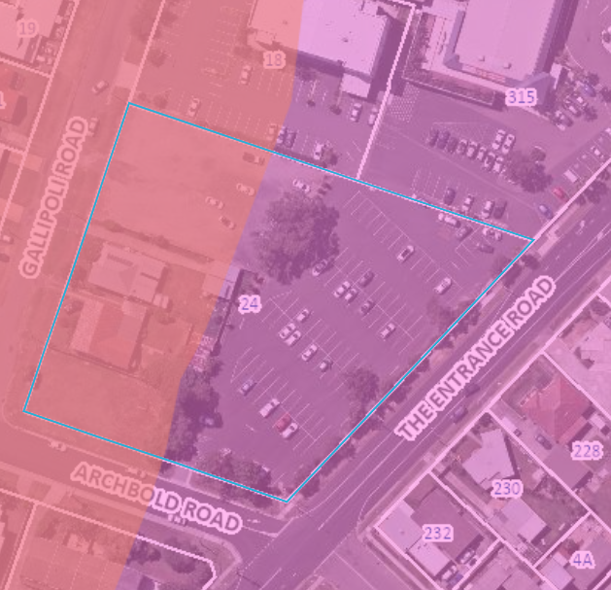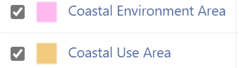

Under the development controls that apply to the coastal environment area under Section 2.10, development consent must not be granted unless the consent authority has considered whether the proposed development is likely to cause an adverse impact on the matters identified under subsection (1)(a)-(g).

The proposal is considered satisfactory with regard to these matters and in accordance with subsection (2) the development is designed, sited and will be managed to avoid an adverse impact referred to in subsection (1). In this regard, the site is located within an established urban environment and has no direct and physical interface with the coast however, due to the elevation of the site relative to the foreshore area, the development will be readily visible from the foreshore and waterway. An assessment has been made of the visual impact of the development on the foreshore area and waterway and it is considered that the development is suitably sited to minimise adverse impacts.

Under the development controls that apply to the coastal use area under section 2.11, development consent must not be granted to development on land that is within the coastal use area unless the consent authority has considered whether the proposed development is likely to cause an adverse impact on matters (i)-(v) and is satisfied the development is designed, sited, and will be managed to avoid any such adverse impact. The site is located over 150m distance away from any direct interface with the foreshore area and is not near any nearby coastal headland.

The site is located within an established urban area and will not impact on any aboriginal, cultural, or built heritage. Additionally, in accordance with subsection (c), the surrounding coastal and built environment, and the bulk, scale and size of the proposed development has been considered in the assessment of the proposal under this section.

State Environmental Planning Policy (Industry and Employment) 2021

Chapter 3 – Advertising and Signage

The provisions of Chapter 3 (Advertising and Signage) SEPP (Industry and Employment) 2021 (SEPP IE) apply to the proposal. The proposed development seeks approval for new identification signage associated with the development. The proposal includes signage (draft logo) to be erected on various elevations of the buildings and at main entry points.

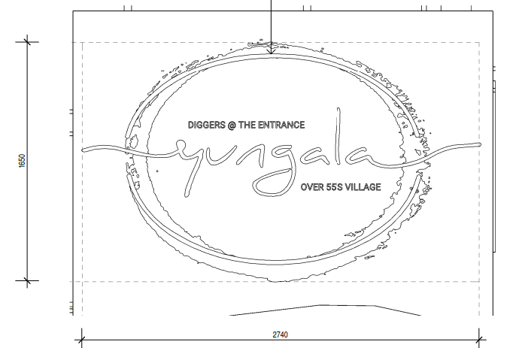
Above: Plan of proposed signage

Under the SEPP IE, the signage would be considered as ‘business identification signs’ and as such, Part 3.3 of the SEPP does not apply to the development. Business identification signage is defined under the standard instrument as:

‘business identification sign’ means a sign:
(a) that indicates:
(i) the name of the person, and
(ii) the business carried on by the person,
at the premises or place at which the sign is displayed, and
(b) that may include the address of the premises or place and a logo or other symbol that identifies the business,
but that does not include any advertising relating to a person who does not carry on business at the premises or place.

In accordance with Section 3.6 of the SEPP, the proposed signage (subject to conditions) is consistent with the objectives of the policy (under Section 3.1(1)(a)) and satisfies the assessment criteria specified under Schedule 5 (Assessment criteria) of the instrument.
State Environmental Planning Policy (Transport and Infrastructure) 2021

- Section 2.119 - Development with frontage to classified road
Section 2.119 requires that prior to granting consent to development with a frontage to a classified road, Council is satisfied as to a number of aspects of the proposal. Under subsection (2) these aspects are identified as:
(a) where practicable, vehicular access to the land is provided by a road other than the classified road, and
(b) the safety, efficiency and ongoing operation of the classified road will not be adversely affected by the development as a result of:
(i) the design of the vehicular access to the land, or
(ii) the emission of smoke or dust from the development, or
(iii) the nature, volume or frequency of vehicles using the classified road to gain access to the land, and
(c) the development is of a type that is not sensitive to traffic noise or vehicle emissions, or is appropriately located and designed, or includes measures, to ameliorate potential traffic noise or vehicle emissions within the site of the development arising from the adjacent classified road.
- Section 2.120 - Impact of road noise or vibration on non-road development
Section 2.120 applies to residential accommodation along a road with an annual average daily traffic volume of more than 20,000 vehicles (based on the traffic volume data published on the website of TfNSW) and that the consent authority considers is likely to be adversely affected by road noise or vibration.
Subsection (3) states:
If the development is for the purposes of residential accommodation, the consent authority must not grant consent to the development unless it is satisfied that appropriate measures will be taken to ensure that the following LAeq levels are not exceeded—
(a) in any bedroom in the residential accommodation—35 dB(A) at any time between 10 pm and 7 am,
(b) anywhere else in the residential accommodation (other than a garage, kitchen, bathroom or hallway)—40 dB(A) at any time.

The proposal includes residential accommodation and is located along a classified road and an acoustic report was provided with the proposal which addressed road noise intrusion. TFNSW advised:
“the developer, not TfNSW, is responsible for providing noise attenuation measures in accordance with the ‘NSW Road Noise Policy 2011’, prepared by the department previously known as the Department of Environment, Climate Change and Water. If the external noise criteria cannot feasibly or reasonably be met, TfNSW recommends that Council apply internal noise objectives for all habitable rooms with windows that comply with the Building Code of Australia.

Traffic Noise

Based on the performed calculations and the “Road Traffic Noise Criteria”, the units facing The Entrance Road would experience elevated noise without any attenuation measures. Due to the multi storey level design the only mechanism to attenuate any potential impacts would be through the construction materials used for these units, e.g., Balustrade on the deck, Concrete/ Brick for walls/ceilings and floors and double glazing for any glass windows or doors.

The sampling data, methodology and findings of the Noise Impact Assessment and additional addendum acoustic information by Spectrum Acoustics have been reviewed by Council’s Senior Environmental Protection Officer who concurs with the recommendations and noise control measures specified in the acoustic reports. Recommended conditions have been included that ensures that all recommended attenuation measures are adequately applied to ensure that the internal use of each unit is not unreasonably impacted by any outdoor noise sources.

- Section 2.122 - Traffic-generating development
The site is located along The Entrance Road (also known as the Central Coast Highway) which is a classified Road. The proposal does not include any new access onto the classified road, nor does it propose any new access within 90 metres of a classified road. However, the development does take place on land which has existing site access to a classified road. The application was referred to Transport for NSW (TfNSW) for comment under Section 2.122 and comments were received.

The proposed new development is not of a type or scale listed under Columns 1, 2 or 3 of Schedule 3 because Lot 4 does not include a direct or indirect connection to, nor is it within 90 metres of, a classified road, as the development will be accessed via Gallipoli Road, rather than The Entrance Road.
The SEPP references ‘site with access to a classified road’ and TfNSW have provided the following comment.
“the proposed development will have direct pedestrian access to The Entrance Road, a classified State road. The proposed new premises is of a size and capacity listed in schedule 3, column 3 of the TISEPP, and is therefore a traffic generating development from an active transport perspective. TfNSW recommends that consideration be given to the following measures to enhance safety and accessibility for pedestrians and cyclists”. The measures were listed and where relevant has been included under the recommended conditions.

State Environmental Planning Policy (SEPP) No. 65 – Design Quality of Residential Apartment Building and the Apartment Design Guideline (ADG)

State Environmental Planning Policy 65 (Design Quality of Residential Apartment Development) (SEPP 65) applies to the development and requires the design quality of the development to be taken into consideration and evaluated against the design quality principles. Additionally, Clause 30(2) of SEPP 65 requires such development to be designed in accordance with the associated Apartment Design Guide (ADG) as follows:

30(2) Development consent must not be granted if, in the opinion of the consent authority, the development or modification does not demonstrate that adequate regard has been given to:
(a) the design quality principles, and
(b) the objectives specified in the Apartment Design Guide for the relevant design criteria.

The proposal has been designed in accordance with the ADG and a compliance table summarizing the proposal against the ADG has been included as an attachment to the report (refer Attachment B). Several minor variations are sought to the ADG criteria and are outlined below. The following table considers the proposal against the SEPP 65 design quality principles and includes the applicant’s relevant design comments.

Principles | Proposal (Applicant’s response)
Context & Neighbourhood Character | The desirable elements of the locations current character are its proximity to Long Jetty Foreshore Reserve and the amenity provided by the Diggers club. The neighbourhood is characterised by two typologies, the Hotel and Club which embody a larger building type and small residential dwellings of one to two storeys. The proposal facilitates the transition between these two typologies by providing a larger structure with residential materials and distinct individual dwellings to create a human scale, contributing to the quality and identity of the area.  The proposal responds to the local context and neighbourhood character by maintaining an appropriate scale within the planning parameters. It will provide landscaping and planting links to the perimeter and visual connections to the large and central courtyard. The physical link to the club also connects the proposal to the context and neighbourhood.
Built Form and  Scale | The proposal is under both LEP Height limits. It will allow good solar access internally and externally. The height of the buildings responds to the context, with greater height near the larger bulk of the Hotel and Club and lower heights to respond to the smaller scale of the dwellings along Archbold Road and Gallipoli Road. The elements of the building are broken up to provide access to views, privacy and shading and create a human scale to the proposal.  The design responds to the change in levels in the site by creating different pedestrian access points at ground level and creating a vehicular access on Gallipoli Road. The height of the proposal responds to existing height of surrounding buildings by increasing in height towards the hotel and club and reducing in height at Archbold Road where the townhouses across the road are two storeys. The site is also lower in the centre to facilitate views across Tuggerah Lake for the apartments which also breaks up the façade on Gallipoli Road.  The design concept for the proposal is to include a core green space through the centre of the site to create a major open connection for the Development that allows light and natural ventilation flow to the buildings. The height and set back treatment allow maximum solar access to the apartments and to the neighbouring properties.
Density | The FSR for the development is under the LEP FSR controls. The design offers a high level of amenity for residents and each apartment, resulting in a density appropriate to the site and its context. Two-bedroom apartments allow couples and singles to have one bedroom for sleeping and an additional bedroom for guests or hobbies.  The apartments have been designed to facilitate views to Tuggerah Lake, have good solar design and natural ventilation. Each unit has wide windows and doors that allow good solar access and good views and ventilation. Each apartment has the higher level of amenity required for Seniors Living in the form of a larger adaptable bedroom and bathroom and generous living areas.  There are three community outdoor areas which add to the amenity of the residents. The common outdoor area on Level 5 offers broad views across the water for small gatherings. The space on Level 2 contains a community garden, BBQ area and views of the Long Jetty. The core green space on Level 1 provides a green outlook for the courtyard units and provides separation and privacy between units.
Sustainability | The proposed development includes numerous initiatives that contribute to the efficient use of resources, through sustainable design measures and actively managed systems. These can be summarised as follows:  • North – South orientation of the building forms to maximise solar access to the development.  • 78% of apartments receiving 3 hours of direct sunlight to the main living spaces and outdoor areas at midwinter, 83% receive 2 hours.  • 69% of apartments receive natural cross ventilation.  • Operable glazing, including awning windows to allow natural ventilation and reduce heating and cooling requirements.  • Deep recesses on the façade to reduce excessive solar gain and moderate occupant privacy, whilst also allowing for natural ventilation and daylight to the adjacent living space.  • Shading devices designed to provide shade in Summer and allow Solar Access in Winter  • A minimum of 4 hours solar access to existing neighbours’ private outdoor areas.  • Compliance with BASIX, Nathers and Section J  • Selection of low maintenance materials.  • Use of green podiums and planting throughout.  • Low water planting and use of rainwater tanks.  • Re-use of waste and excess materials.  • Use of solar panels.
Landscape | The Proposal includes several areas dedicated to landscaping, which have been integrated into the overall building design. Existing trees are retained on the East Elevation and additional street trees will be planted on all street frontages which will enhance the existing streetscape. Private outdoor areas on the Ground Level are designed to allow gardening opportunities for residents as well as private spaces for relaxation.  There are three generous private common outdoor areas provided for the Residents. The primary area is located on Level 1 in the centre of the site and provides park like surrounds with grassy areas and seating. There is another area located on the roof level of the of the second floor of the West building and includes a viewing platform to Long Jetty, a BBQ area, and a community garden. Another private common outdoor area is located on Level 5 of the East building and features similar facilities and sweeping views.
Amenity | Residential apartments within the proposed development have been planned to maximise amenity. This has been considered in relation to solar access, visual privacy, cross ventilation, and outlook, and ensures consistency with SEPP 65 and the Seniors SEPP.  The overall building massing and placement on the site has been largely driven by opportunity for solar access. As such, a minimum of 78% of dwellings receive 3 hours of direct sunlight to living areas in midwinter. Outdoor areas have been carefully placed to prevent overlooking and shield excessive solar gain, whilst allowing daylight penetration. Openings are maximised where living areas and balconies are located. The result is a composition which carefully considers and satisfies the amenity principles required by the SEPP.  Acoustic privacy has been assessed in the Acoustic Report and will require a higher level of acoustic treatment to windows that face the Central Coast Highway. The main carpark entry located on Gallipoli Road controls vehicular access to the site which negates traffic movement to the site from the Central Coast Highway.  Stormwater design has been considered and incorporated into the landscape design to create a feature with a rainwater garden provided on the south west corner, near the main entry. The proposal maximises the provision of recycling facilities, for further details refer to the Landscape drawings and Stormwater plans.
Safety | The design proposes the following security measures to restrict, control and manage communal access in and around the proposed development:  • Residential entry points and circulation areas are clearly identified and securable.  • Central location of the communal green open space allows passive surveillance.  • Screened windows at lower levels offer privacy whilst allowing for passive surveillance.  • High quality and discreet architectural lighting throughout the development will assist in securing the area at night.  • CCTV security system will enable security measures and management for the development.
Housing Diversity and Social interaction | Apartment planning has been carefully considered throughout the development to ensure layouts remain universal and flexible to provide for a range of occupants. Solar access has played a significant role, with living rooms generally located on the Northern façade. Internal apartment areas and room sizes have been designed in accordance with SEPP 65 requirements. 87 apartments for residents are two bedroom to allow for a demographic majority for Seniors Living, mainly singles and couples over 55. There are an additional two three-bedroom units for Managers.  The proposal encourages social interaction with a physical link to Diggers at The Entrance that allows Residents to easily access the facilities there and interact with other locals. All the apartments are designed in accordance with the Seniors SEPP and are adaptable, allowing efficient and compliant refurbishment into accessible units should the need arise. The proposal also provides a safe, secure, and accessible pathway to each common outdoor area and apartment.
Aesthetics | The proposed development is intended to set a precedent for quality design with respect to the future built environment for Long Jetty. Façade treatment has been carefully considered as a means of creating an aesthetic modulation of the buildings by presenting a coordinated cohesion of the streetscape, as well as providing a balanced composition which responds to internal apartment planning. A detailed layering of materials, recesses and colour have been used to ensure a high-quality architectural expression and to offer amenity to apartments as described in Principle No. 6.  Materials including a combination of sandstone, brick, render, timber, painted steel and glazing offer a variety of textures and colours which contribute to the overall façade articulation. Sandstone hues have been selected as a response to the local materials. These materials are considered appropriate for the local climate, are durable and require low maintenance. The sun-screening above is a gabion floating roof that utilises material waste of stone and brick to create dappled shading and privacy to Ground Floor areas.  There is also a layer of planting that separates the Ground Level from the areas below. Recycled timber shading devices are provided on windows to the East and West. This timber shading reflects the Long Jetty wharf.  The result is a considered overall building design which responds to the principles of scale, proportion, and composition. The façade detail and proposed finishes will offer a positive contribution to the desired future character of the area.

- Objective 4K-1 – A range of apartment types and sizes is to be provided to cater for different household types now and into the future.
Design Guidance - A variety of apartment types is provided. The apartment mix is appropriate.

The proposal includes 87 x 2 bedroom dwellings and 2 x 3 bedroom dwellings (which are for the on-site managers). The ADG identifies that a mix of apartment types provides housing choice and supports equitable housing access...This is particularly important because apartment buildings form a significant and often long term part of the urban fabric. The ADG recommends that flexible apartment configurations should be provided to support diverse household types and stages of life (including single person households, families, multi-generational families, and group households).
A non-numerical variation is sought based on the argument provided by the applicant that the greatest demand for seniors housing is for 2 bedroom dwellings. The applicant argues that the proposal includes housing directly tailored to the ageing population and meeting its housing needs. All but two of the new dwellings are 2 bedroom apartments which are small scale housing, suitably sized and designed to cater for many older residents.
The applicant has argued that the Australian Bureau of Statistics indicates that 34.8% of residents of Long Jetty are over fifty years. The data reveals that approximately 50% are couples, which favours the demand for two bedroom apartments in the development. The applicant argues that older households are typically a smaller household size and the housing is proposed to cater for this demographic. All the apartments will have a high level of residential amenity located within an established local community, adjoining an existing registered club in an area with recreational opportunities.
The apartment mix is considered appropriate considering the location of the site and its proximity to public transport and services, and the demand for seniors housing in the area. The variation in this instance is considered reasonable.

- Objective 4A-1 – To optimise the number of apartments receiving sunlight to habitable rooms, primary windows and private open space
Design Criteria 3 - A maximum of 15% of apartments in a building receive no direct sunlight between 9 am and 3 pm at mid winter
The proposal includes a minor variation (4%) to the above ADG criteria as 15.7% of apartments (14 units) will receive no solar access mid-winter. It is considered that the objective for the criteria outlined above is satisfied. The single aspect south facing apartments is minimised in the design.
In this regard, the development as a whole more than meets the design criteria under objectives 1 and 2 in that 80% of the living areas and Privat Open Space (POS) area of all units within the development receive a minimum of 3 hours direct sunlight between 9 am and 3 pm at mid-winter. In this regard, the variation is considered reasonable.

- Objective 4E-1 - Apartments provide appropriately sized private open space and balconies to enhance residential amenity
Design Criteria 1 - All apartments are required to have primary balconies as follows: 2 bedroom apartments are have a minimum area 10m² & minimum depth 2m

The proposal is satisfactory given 86 of the 89 apartments all comply. There are three apartments with balconies that don’t comply. The development includes balcony areas of between 9.3m² – 88m² with a minimum dimension of 2. The three units that don’t comply are U43 with a balcony area of 9.9m², U45 with a balcony area of 9.3m² and U62 with a balcony area of 9.3m². All the courtyards at ground level within the development comply with the ADG minimum areas and dimensions having areas sized between 21m² – 102m².

The variation is minor and only applies to 3 out of 89 apartments. It is noted that the POS of each of these three units has a good level of amenity being oriented westwards overlooking Communal Open Space (COS) and will likely be afforded views of the lake. Additionally, the COS provided within the development is in excess of the minimum areas required under the ADG and DCP (with 25% of site area required and 28% provided) and has a high level of amenity with views towards the lake. Despite the variation the POS areas within the development are considered reasonable and satisfactory.
State Environmental Planning Policy (Housing for Seniors or People with a Disability) 2004
The proposal has not been lodged under the provisions of State Environmental Planning Policy (Housing for Seniors or People with a Disability) 2004 and the DA does not rely upon the SEPP for permissibility or any development bonuses. Therefore, a Site Compatibility Certificate has not been sought under the SEPP as the development for seniors housing is permissible under the Additional Permitted Uses provisions in Schedule 1 of Wyong LEP 2013.

State Environmental Planning Policy (Building Sustainability Index: BASIX) 2004

The proposed development constitutes ‘BASIX affected development’ as defined within the Regulations, and, in accordance with the SEPP, a valid BASIX Certificate (1195594M) has been submitted with the development application. The proposal complies with the requirement for the proposed dwellings to meet the NSW Government’s requirements for sustainability in residential buildings in terms of meeting water and energy efficiency targets.

State Environmental Planning Policy (Housing) 2021
The SEPP (Housing) 2021 commenced on 26 Nov 2021.The DA was lodged prior to the commencement of this SEPP (September 2021) and the savings provisions under Schedule 7A (Savings and transitional provisions) apply to the application and state:
2 General savings provision
(1) This Policy does not apply to the following matters—
(a) a development application made, but not yet determined, on or before the commencement date…

Central Coast Local Environmental Plan 2022 (CCLEP 2022)

Central Coast Local Environmental Plan 2022 (CCLEP) was published 24 June 2022 and commenced on 1 August 2022 and has been considered in the assessment of the application. However, in accordance with the savings provisions, this application was lodged prior to the commencement of the new Plan and as such the provisions of the WLEP 2013 continue to apply. CCLEP 2022 contains a savings and transitional provision that provides at clause 1.8A:

‘If a development application has been made before the commencement of this Plan
in relation to land to which this Plan applies and the application has not been finally
determined before that commencement, the application must be determined as if this
Plan had not commenced.’

Under the published and adopted CCLEP, there is no change to the zoning of the site and no significant change to other relevant statutory matters as they apply to the proposal under CCLEP.

Wyong Local Environmental Plan (WLEP) 2013

Permissibility and zone objectives

The site is located within the RE2 Private Recreation pursuant to Clause 2.3 of the Wyong Local Environmental Plan (WLEP) 2013.

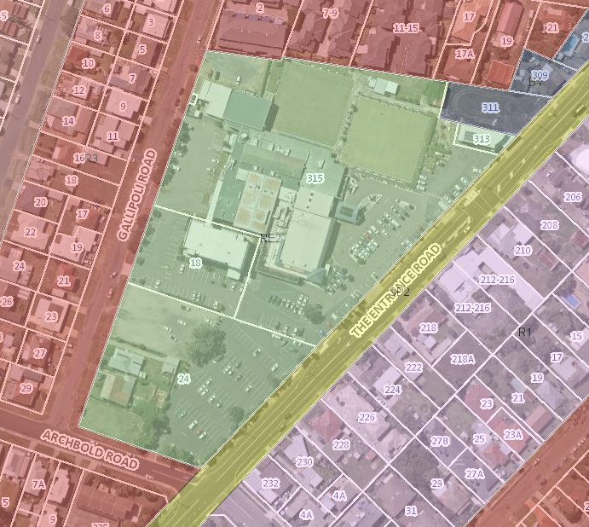
Above: Zoning map of the site under WLEP 2013

The proposed development is defined as Seniors Housing which is defined as follows under WLEP 2013:

Seniors housing means a building or place that is—

- a residential care facility, or
- a hostel within the meaning of clause 12 of State Environmental Planning Policy (Housing for Seniors or People with a Disability) 2004, or
- a group of self-contained dwellings, or
- a combination of any of the buildings or places referred to in paragraphs (a)–(c),

and that is, or is intended to be, used permanently for—

- seniors or people who have a disability, or
- people who live in the same household with seniors or people who have a disability, or
- staff employed to assist in the administration of the building or place or in the provision of services to persons living in the building or place,

but does not include a hospital.

Note. Seniors housing is a type of residential accommodation—see the definition of that term in this Dictionary.

Seniors housing is prohibited in the zone under clause 2.3 of WLEP 2013. However, the site is identified as ‘item 4’ under Schedule 1 (Additional Permitted Uses) which permits development for the purposes of seniors housing if the development is associated with a registered club in accordance with clause 2.5.

Clause 2.5 of WLEP reads:

2.5 Additional permitted uses for particular land

(1) Development on particular land that is described or referred to in Schedule 1 may be carried out—
(a) with development consent, or
(b) if the Schedule so provides—without development consent,
in accordance with the conditions (if any) specified in that Schedule in relation to that development.
(2) This clause has effect despite anything to the contrary in the Land Use Table or other provision of this Plan.

Schedule 1 (Additional Permitted Uses) or WLEP reads:

Use of certain land at Bateau Bay, Canton Beach, Doyalson, Gorokan, Gwandalan, Halekulani, Killarney Vale, Lake Munmorah, Norah Head, Ourimbah, Shelly Beach, The Entrance, Toukley, Tumbi Umbi and Wyong

(1) This clause applies to the land identified as “Item 3”, “Item 4”, “Item 5”, “Item 6”, “Item 7”, “Item 8”, “Item 9”, “Item 10”, “Item 11”, “Item 12”, “Item 13”, “Item 14”, “Item 15”, “Item 16”, “Item 17”, “Item 18”, “Item 19”, “Item 20” and “Item 21”on the Additional Permitted Uses Map.
(2) Development for the purposes of hotel or motel accommodation, residential care facilities, seniors housing and serviced apartments is permitted with development consent if the development is associated with a registered club.

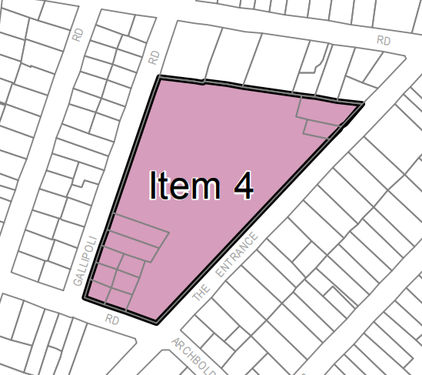
Above: Extract from the WLEP Additional permitted uses map

The proposed development is to be associated with the existing Diggers RSL club and as such is permissible with development consent if this association can be satisfactorily demonstrated.

The applicant is relying on the following aspects of the proposal to demonstrate compliance with the above clause:

- physically
– via the physical link to the Club at the north-eastern of the site, which comprises a dedicated pathway and covered walkway – see sheets A101 and A107.
- legally (or via title) –
via the updated CMS, which specifically states that lot 4 must, or can only, be used as seniors housing in accordance with the Retirement Village Act 1999 and the accompanying Operations Agreement, which provides further details of the association between the Club and the proposed development: and
- socially
                - - via membership of the Club, with each resident being provided membership of the Club as part of the purchase of their apartment and in doing so, gaining full access to the use of the Club and its numerous dining facilities, restaurants and bars and other facilities and being conferred with voting rights as to the running of the Club;
                - - via membership of, or participation in, the many sporting clubs based at Diggers, such as the bowling, darts and snooker clubs; and
                - - via participation in the many community groups and hobby/special-interest groups that use Diggers as their base.

- Zone objectives

Under Clause 2.3 of WLEP, the RE2 zone objectives read as follows:

• To enable land to be used for private open space or recreational purposes.
• To provide a range of recreational settings and activities and compatible land uses.
• To protect and enhance the natural environment for recreational purposes.
• To offer opportunities for tourism development that is compatible with the natural environment.
• To allow for alternative uses of open space areas for community purposes that are compatible with surrounding areas.
• To enable land uses that are compatible with, and complementary to, recreational uses.

- Subdivision

Clause 2.6 requires consent be obtained for subdivision and in accordance with this clause the application has also been lodged for strata subdivision of the completed development.

Clause 4.1 which restricts subdivision of lots to the minimum included under the adopted minimum lot size map. This clause is not relevant to this proposal as subclause (4) states:

This clause does not apply in relation to the subdivision of any land—
(a) by the registration of a strata plan or strata plan of subdivision under the Strata Schemes Development Act 2015

- Building Height

Clause 4.3 limits the height of a building to the maximum height shown for the land on the height of buildings map. The map indicates that there are two height limits that apply to the land comprising the site. The building heights are 16m and 8.5m as shown in the map below.

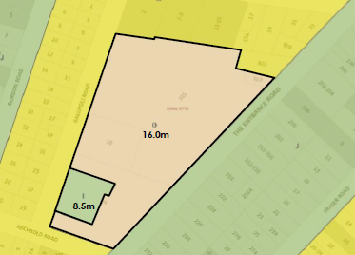
Above: WLEP Height of buildings map

The proposal demonstrates compliance with the maximum height applying to the specified parts of the site.

- Floor Space Ratio

Clause 4.4 limits the maximum floor space ratio for a building as shown on the Floor Space Ratio Map. The map indicates that there are two FSR limits that apply to the land comprising the site. These FSR’s are 0.85:1 and 0.5:1 as shown in the map below.

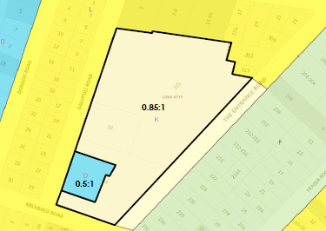
Above: WLEP FSR map for the site

The proposed FSR was originally based upon the site area (and existing GFA) within both Lots 3 and 4 (and not including Lots 1 and 2). The original calculation demonstrates compliance. However, the existing gross floor area (GFA) for the hotel on Lot 2 predated the community title subdivision of the site and as such was based on a total site area that included the area of current Lot 3 (containing the club) and part of the area known as Lot 4. The applicant has prepared a revised calculation of the FSR that includes the GFA for the existing development on Lot 2 (i.e., the hotel) along with the site area of Lot 2 in the calculation of total FSR. The original and revised calculation of FSR demonstrates that the proposal complies.

The GFA is calculated on the basis of the FSR map and the respective FSR that applies to the GFA within that mapped area. The part of lot 4 within Category D with an FSR of 0.5:1 has a site area of 2,011m². The proposed GFA of the section of the building to be erected
within the Category D area is 992m². When compared to the site area of Category D of 2,011m², this floor space would result in a FSR of 0.49:1, which complies.
The remainder of lot 4 (i.e., the section within Category K with an FSR of 0.85:1) and all of lot 3 has a site area of 21,873m². The proposed GFA of the part of the building to be erected within Category K on lot 4 is 7,503m², and the GFA of the existing Club is 8,060m², giving a total gross floor area of 15,734m². When compared to the total site area of Category K of 21,873m² across the site, this would result in an FSR of 0.72:1, which complies.

Lot 2 has a maximum applicable FSR of 0.85:1 and based on a site area of 2670m² and a GFA of 1999m², the existing FSR on Lot 2 is 0.75:1 which complies. When Lots 2, 3 and 4 are all included the site area (creating a combined site area of 24,543m² and GFA of 17,733m²), the existing and proposed GFA results in a compliant FSR of 0.72:1.

The applicant has advised of compliance for the proposed development with both applicable FSR controls across the site (being combined Lot 3 and 4). It is however, noted that were the FSR to be assessed for Lot 4 in isolation (ie. without inclusion of the Lot 3 club site), the proposed GFA of 8666m² on a site area of 7143m² would result in an FSR of 1.2:1 which would exceed the LEP control. However, lots 3 and 4 are part of a community title subdivision with numerous management and operational plans (and a long-term strategic planning context) which link the two sites in a relationship with each other, and as such the proposal is considered satisfactory with regard to addressing the FSR control.

- Acid Sulfate Soils

Clause 7.1 requires consideration be given to development on land that is mapped as being subject to actual or potential acid sulfate soils (ASS). The subject site has been identified as containing potential Class 1, 2 and 5 acid sulfate soils. The site is mapped as potentially containing acid sulfate soils (Class 5) and under Clause 7.1 this has been assessed. Under the clause, works within Class 5 that trigger the requirement for preparation of an Acid Sulfate Soils Management Plan are:

Works within 500 metres of adjacent Class 1, 2, 3 or 4 land that is below 5 metres Australian Height Datum and by which the watertable is likely to be lowered below 1 metre Australian Height Datum on adjacent Class 1, 2, 3 or 4 land.

The site is located within 500m of adjacent Class 3 and potentially Class 2 land, and a preliminary assessment of the proposed works for ASS was carried out. The assessment did not identify any Potential ASS or Actual ASS on the site, with all (16) samples screened for PASS within allowable chemical limits and concluding the risk from ASS is low and further assessment was not required. It is noted that the works are well above RL 5.0m AHD and are unlikely to lower the watertable below RL 1.0m AHD. An ASSMP is therefore not required.

- Essential services

Clause 7.9 states that development consent must not be granted to a development application unless the consent authority is satisfied that the services that are essential for the development are available or that adequate arrangements have been made to make them available. This includes the supply of water, electricity, the disposal and management of sewer, stormwater drainage and suitable vehicle access. In accordance with Clause 7.9, satisfactory servicing has been demonstrated for the development as discussed below.

The site is currently connected to Council’s reticulated water and sewerage infrastructure. An existing 300mm AC water main is located within The Entrance Road site frontage, with three connections (and meters) servicing the site currently (expected to be off the water main on the opposite side of Gallipoli Road). Any water main upgrades required to service the development will be included in the Water Management Act (WMA) Section 306 Requirements letter.

Existing 150mm AC sewer mains (and associated manholes) are located within the Archbold and Gallipoli Road site frontages, as well as a sewer main traversing the centre of the proposed development site (Line A20) which enters the site approximately halfway along the Gallipoli Road frontage, extending ¾ of the way across the site to the east, then turning north (at a manhole within the subject site) and exiting the site under the north property boundary, to service No. 315 The Entrance Road (Digger’s Club site). This sewer main will be impacted by the development and will need to be decommissioned.

The Applicant advised the existing main through the site was found to be full of dirt and debris, with no sewer flow, and deemed to be not in use, supporting the decommissioning and removal of this main through the site (or diversion around the works). Council’s Team Leader (Water Assessments) has advised they concur with the removal of the traversing gravity sewer mains between MH 2005, A20C01 and A20CDE.

The development is required to be designed and constructed in accordance with Council’s Building in Proximity to Water and Sewer Pipelines Policy. The Applicant has submitted a Combined Services Plan, prepared by EWFW (Job No. 22315, Rev. 01) which details relocation of the existing sewer main through the site, and associated manhole, to be immediately within the northern property boundary.

Council’s Team Leader (Water Assessments) has also noted that the proposed carpark entry from Gallipoli Road will likely impact the existing sewer main along Gallipoli Road and that the applicant will be required to reline this existing sewer main.

The applicant is required to confirm the alignment of the existing 300mm water main along The Entrance Road. Any works in the vicinity of the trunk main will need to comply with Council’s requirements (details are to be included in the Section 306 letter). No connection can be made towards the existing 300mm main. The proposed development will be connected to the existing water main along Gallipoli Road or Archbold Road.

The development will require a Section 307 Certificate under the Water Management Act 2000. Water and sewer contributions are required for this proposal, which will be detailed on the WMA Section 306 Requirements letter. The proponent will be required to submit a Section 305 application and obtain the Section 307 certificate prior to issue of the Occupation Certificate. Detail design will be reviewed as part of the Section 305 application assessment. Water and Sewer developer charges will be applicable for the proposed development.

Other services including electricity, telecommunications, and gas services, are currently provided to the site and these services will be upgraded and extended to the new buildings as required. It is noted that there are existing services within proximity to / underneath the proposed site stormwater discharge pipe through the road reserve and filled retained area surrounding the OSD (including a telecommunications pit shown under the corner of this retaining wall). The Applicant will be required to coordinate with the relevant Authority(s) for any required asset relocations.
Arrangements will be made for the satisfactory servicing of the new development for the provision of vehicular access and satisfactory stormwater management subject to recommended conditions.

  - Section 4.15 (1)(a)(ii) - Provisions of any Proposed Instruments

There are several proposed instruments which have been the subject of public consultation under the EP&A Act, and which may be relevant to the proposal, including the following:

- Draft Remediation of Land SEPP
- Draft Design and Place SEPP

- Draft Remediation of Land SEPP
The key operational framework of the former SEPP 55 is maintained in the new SEPP which will still require consent authorities to consider whether the site is, or is likely to be, contaminated, and permit a consent authority to require additional information to satisfy itself as to whether the land is contaminated.
Having regard for the Explanation of Intended Effect, and the site history of use as a recreational area and registered club, the proposed development is considered satisfactory with regard to the requirements of the draft SEPP.
- Draft Design and Place SEPP
In her recent instructions to local government, the Secretary emphasised that, for the purposes of section 4.15(1)(a)(ii) of the Environmental Planning and Assessment Act 1979, the draft proposed Design and Place SEPP 2021 is not notified to any consent authorities and is therefore not a mandatory matter for consideration under the Act. The Draft SEPP is not to be applied to the assessment of development applications until the policy is finalised.

  - Section 4.15(1)(a)(iii) - Provisions of any Development Control Plan

- Central Coast Development Control Plan 2022 (CCDCP 2022)
The Central Coast Development Control Plan 2022 (CCDCP 2022) came into force on the same date as CCLEP2022 (1 August 2022). Chapter 1.1 of the CCDCP 2022 contains savings provisions and provides that, consistent with the provisions of CCLEP2022, if a development application has been made before the commencement of this DCP and the application has not been finally determined before that commencement, the application must be determined as if the DCP had not commenced. As such, this application has been considered against the Wyong Development Control Plan 2013.

- Wyong Development Control Plan 2013

The following Chapters of Wyong Development Control Plan 2013 (‘the DCP’) are relevant to this application:

- Chapter 1.2 - Notification of Development Proposals
- Chapter 2.4 - Multiple Dwelling Residential Development
- Chapter 2.6 – Signage
- Chapter 2.11 - Parking and Access
- Chapter 3.1 - Site Waste Management
- Chapter 5.3 – The Entrance Peninsula

DCP Chapter 2.4 - Multiple Dwelling Residential Development
DCP Chapter 2.4 - Multiple Dwelling Residential Development applies in so far as those planning controls not already included under the other instruments, plans and policies that prevail. In this regard the provisions of the ADG contain more specific planning controls that have been applied rather than the similar controls applying under the DCP Chapter.
The proposal is considered generally consistent with the relevant aims and requirements of DCP Chapter 2.4. A numerical table (Attachment C) accompanies the report and outlines the relevant aspects of the proposal with regards to compliance with the planning controls under DCP Chapter 2.4.
There are several requirements under the DCP that are relevant to the proposal but are overridden by similar controls contained within the ADG. These DCP requirements include:
• Communal open space (10m² per dwelling with a minimum dimension of 5 metres),
• Private open space (a minimum area of 10m² and a minimum dimension of 2m),
• Deep soil provision (12.5% site area),
• Site coverage (soft landscaping 25%),
• Solar access (70% dwelling minimum of 3 hours midwinter between 9am-3pm),
• Storage (3m² of floor area/1-2bed dwelling),
• Parking provision for dwellings (1 space/1bedroom and 1.2 spaces/2bedroom
There are a number of other controls under the DCP that are relevant and apply to the proposal that are not provided within the ADG. The proposal includes the following compliance with or variations to, Council’s DCP requirements for residential flat buildings as discussed below.
The proposal includes the following variations to Council’s DCP requirements for residential flat buildings.

Clause | 4.3.3– Building Lines- Residential Flat Buildings – 3 or more storeys in height
Standard and Design Guidance | Side and Rear setbacks - Fifth Storey: 9.0 metres
DCP | Chapter 2.4 Multiple Dwelling Residential Development
Departure basis | 33% variation to the setback of the fifth storey

DCP Clause  ADG Objective | 12.1a – A variety of dwelling types 1, 2, 3, & 4 bedrooms  4K-1 - A variety of apartment types and sizes to cater for different household types now and into the future
Standard and Design Guidance | Dwelling mix
DCP & ADG | Wyong DCP Chapter 2.4 – Multiple Dwelling Residential Development  Apartment Design Guide - NSW Planning & Environment
Departure basis | 87 x 2 bedroom and 2 x 3 Bedroom. Non numerical variation based on satisfying existing demand for smaller dwellings.

Clause | 6.3.3 – Solar access – Residential Flat Buildings
Standard and Design Guidance | Maximum 10% of dwellings with a southerly aspect (SE-SW) (DCP)  ADG allows a maximum of 15% apartments to have no solar access midwinter
DCP | Chapter 2.4 Multiple Dwelling Residential Development
Departure basis | 15.7% of dwellings do not achieve compliance which equates to 14 dwellings.

Clause | 4.4.4 - Bicycle Facilities
Standard and Design Guidance | For development where resident car parking for the development is provided in a common car park area, bicycle parking facilities shall be provided at a rate of 1 per 3 dwellings.
DCP | Chapter 2.4 Multiple Dwelling Residential Development
Departure basis | Non numerical as no bicycle parking is provided for the development.

Clause | 10.1.2 - Residential Flat Buildings 3 or more storeys in height -Waste Chute
Standard and Design Guidance | - Garbage chute systems are required for developments exceeding three storeys or containing a passenger lift  - Developments which include a garbage chute system must contain recycling rooms on each floor to accommodate one day’s volume of recyclables, which are then to be transported to the bin storage room(s)
DCP | Chapter 2.4 Multiple Dwelling Residential Development
Departure basis | Non numerical – no waste chute proposed.

- Building Lines - Setbacks

With regard to setbacks (which are not included under SEPP 65 or ADG), the proposal generally complies. The development complies with the required front setback of 7.5m on all three street frontages and the rear/side setback of 6m under the DCP applying to the northern boundary adjoining the club but only up to the fourth storey. The DCP requires that for 1-4 storeys the rear/side setback is 6m but for the fifth storey it increases to 9 metres. The proposal therefore includes a minor variation to the fifth storey setback as a 6m setback at this level is maintained.

The applicant has argued that as the ground floor of the building at this part of the site is positioned beneath ground level then there are only four levels technically positioned above ground level and each of the proposed four levels above ground level thereby comply with the 6m setback requirement.

The objectives for the ‘building lines’ control under the DCP include:

• To maintain existing streetscapes
• To protect the privacy and solar access of adjacent properties
• To ensure the visual focus of a development is the dwelling, not the garage
• To maximise building separation to provide visual and acoustic privacy

It is noted that the adjoining development on this boundary is the club and there are no adverse impacts to amenity or visual bulk and scale resulting from the variation. The setback will not be readily visible from the street. There are no significant or unreasonable impacts to the solar access or visual or acoustic privacy of any adjacent properties as a result of the variation. The side elevations of the building are satisfactorily articulated both vertically and horizontally and openings are suitably designed to minimize privacy impacts. Despite the variation proposed it is considered that the proposal demonstrates compliance with the objectives for the control under Clause 4.3 of Chapter 2.4.

- Dwelling mix

A dwelling mix is required under Clause 12.1 of the DCP. The objectives for the control include:

To provide a diversity of apartment types, which cater for different household requirements now and in the future
To maintain equitable access to new housing by cultural and socio-economic groups
To encourage housing designs which meet the broadest range of occupants’ needs
To encourage adaptive re-use
The proposal includes 87 x 2 bedroom apartments and 2 x 3 bedroom apartments (for the on-site managers). A non-numerical variation is therefore sought to the requirement for dwelling mix based on satisfying existing demand for smaller dwellings for older residents.

There is a demographic trend towards smaller households and an ageing population and the need to provide seniors housing in locations with good access to transport, health and community services. There is also a disproportionately large representation of single or lone person households in this area compared with the NSW average. The proposal is aiming to provide housing to meet an identified demand in the community. The variation is considered reasonable in the circumstances that apply.

- Solar access

Under Clause 6.3.3 a maximum of 10% of dwellings within a residential flat building shall have a southerly aspect (SE-SW). The proposal includes 15.7% or 14 apartments who do not received solar access mid-winter to their living areas or POS.

However, despite this variation the proposal demonstrates compliance with Clause 6.3.3 of the DCP which requires that 70% of dwellings receive a minimum of 3 hours unobstructed sunlight between 9 am and 3 pm on June 21 (winter solstice) to living rooms and private open spaces. The proposal exceeds this requirement as 80% of apartments will achieve the 3 hours mid-winter. This requirement is consistent with the provisions of the ADG.

The DCP objectives under Clause 6.3 (Solar Access) for these two controls are as follows:

To provide adequate natural lighting and minimise the need for artificial lighting during daylight hours
To ensure that a minimum standard of solar access is available to private open space areas and internal living areas during the winter solstice to provide for a reasonable standard of residential amenity

The location of the site will afford future occupants a high level of amenity as the units will benefit from a central and well serviced location.

- Bicycle facilities

The DCP (Clause 4.4.4) requires provision of bicycle parking facilities at a rate of 1 space per 3 dwellings. This differs to the requirement under DCP Chapter 2.11 as discussed below.
The applicant seeks a variation to this requirement citing that the age of the residents will make it likely that these facilities will be underutilized and for those residents who own a bike, they can store it within their basement storage area. The applicant has confirmed that a basement storage area of the size required under the ADG (and Council’s DCP) has been provided for each unit. In lieu of the bike parking the applicant is providing motor scooter storage with charging stations for residents in the basement.
The variation is considered reasonable in this instance given the nature of the development and that an adequately sized storage area within the basement is available for each apartment, should they wish to keep a bicycle.
- Waste Management

Clause 10.1.2 requires provision of a garbage chute system for developments exceeding three storeys or containing a passenger lift. The proposal contains a passenger lift, however, no chute system for waste is proposed. The applicant has argued:
When designing the waste areas there were three options that we considered: a central waste area, waste chutes or a waste area located next to the lift cores in the basement area. Having waste chutes on each level can lead to odours that are undesirable, so we chose the option of placing the waste areas in the utilitarian space of the carpark, close to each lift core. These areas are easily cleaned and are easy for residents to access. It also means there is no need for bins to go into lifts which is often necessary for recycling bins, which can also cause odour issues in the lifts. Each waste area is placed close to the lift core of the block it corresponds to and restricts the odours to this area. Waste pick up services if required is available to residents on request as part of Body Corp management.
The DCP objectives under Clause 10.1 (Waste Management) for the control are as follows:

To avoid the generation of waste through design, material selection and building practices
To plan for the types, amount and disposal of waste to be generated during demolition, excavation and construction of development
To encourage waste minimisation, including material separation, reuse and recycling
To ensure efficient storage and collection of waste and quality design of facilities

The revised Operational Waste Management Plan demonstrates that the development is satisfactory with regard to waste storage and management within the basement. The distances from each unit to the lift and then from the lift core to the waste storage room are reasonable. The proposal is considered consistent with the objectives despite not meeting the control requiring a waste chute.
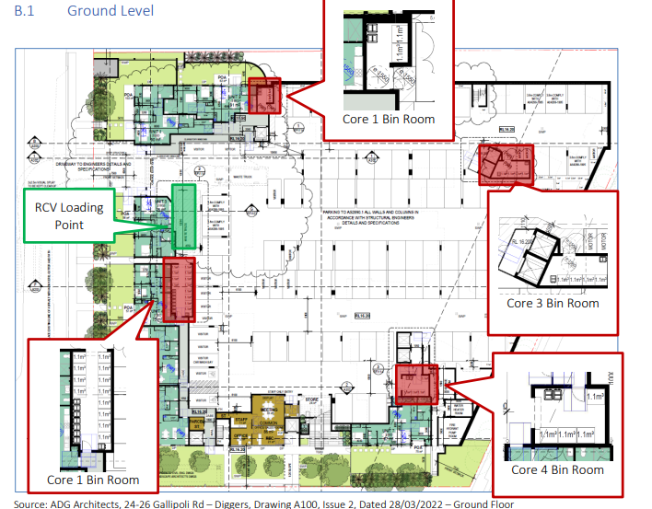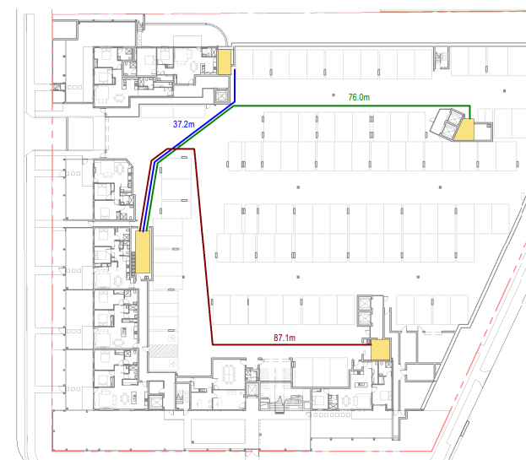
Above: Waste storage and collection arrangement in the basement with distances

- Visual and Acoustic Privacy & Separation Distances

The DCP requires that the development proposal provide and maintain visual and acoustic privacy. There is sufficient separation between the proposal and existing surrounding residential development by virtue of the three street frontages of the site. No variation is proposed to these controls.
The DCP identifies that visual privacy shall be minimised by building layout, location and design of windows and balconies and screening devices. Initially concerns were raised regarding the overlooking and separation between a number of units within the development. However, the plans were revised (to include the use of fixed or operable screens, deletion of windows, and reconfiguration of living areas) to ensure that the development internally provides sufficient visual privacy for future residents.
The amended proposal achieves a good level of amenity, outlook, views and privacy for the future occupants and the existing surrounding residential activities, without compromising the privacy of other residents within the development and surrounding areas.

Overall, the proposal is generally consistent with the relevant aims and requirements of DCP Chapter 2.4 and is considered satisfactory subject to recommended conditions.

DCP Chapter 2.11 - Parking and Access
- Parking Demand Compliance

The DCP requires parking for the development as outlined in the table below.

Land Use | Parking Requirements
RESIDENTIAL ACCOMMODATION
Multi Dwelling Housing and Residential Flat Buildings | 1 space per 1 bedroom dwelling  1.2 spaces per 2 bedroom dwelling  1.5 spaces per 3 (or more) bedroom dwelling  Note: The above requirements may be reduced to 1 space per dwelling if development is in a major centre or a town centre, subject to submission of a Transport Management Plan and approval by Council.  In addition, 1 space per 5 units for visitor parking with a minimum of 1 visitor space per development  1 visitor space is to be available for car washing  On average, only one space per unit is to be allocated as resident parking. The remaining spaces are to be provided as separate parking and available for common use at all times
The proposal includes 87 x 2 bedroom apartments generating a 104.4 spaces plus 2 x 3 bedroom apartments generating 3 spaces which results in a total parking demand of 107.4 spaces for the units. In addition, the DCP requires 17.8 visitor spaces which results in a total parking demand under the DCP Chapter for 126 spaces.
The proposal provides a total of 106 parking spaces for the development. Under the DCP Chapter this would be a shortfall of 18 spaces (14%), however, the proposal is for Seniors Housing and the parking rate under the relevant SEPP prevails for the purposes of the DCP and the proposal complies. The SEPP requires 90 resident spaces, and no visitor parking is required.
Of the 106 spaces provided, 90 are for residents and the remaining 16 are visitor spaces therefore complying with the parking provisions specified in SEPP HSPD. The development also provides 3 motorcycle spaces (which complies with the requirement for 1 mc space/50 other spaces), 43 motor scooter storage spaces, 8 accessible parking spaces (including 2 visitor). There is sufficient provision made for appropriate access for emergency vehicles and satisfactory provision for accessible parking.
DCP Chapter 2.11 under Clause 4.4 and 4.6 requires that there must be adequate provision made for the manoeuvring, loading, and unloading of vehicles on the site. Loading and unloading for the development and garbage collection for the residential use will occur within the basement area and sufficient information has been provided to demonstrate the arrangements are satisfactory subject to conditions.
Adequate provision has been made for the manoeuvring, loading and unloading of vehicles on the site. In this regard, the basement carpark has been satisfactorily designed to cater for an 11m rigid truck. Plans have suitably demonstrated that entry and departure to the service area is in a forward direction only.
The following DCP variation is sought under the application. There is no equivalent provision under SEPP HSPD.
- Bicycle Parking
Clause | 3.8 - Bicycle parking
Standard and Design Guidance | d. For residential flat development comprising six or more dwellings and where resident carparking for the development is provided in a common carpark area, bicycle parking facilities shall be provided at a rate of one per three dwellings.  e For any other type of development (excluding residential) bicycle parking facilities shall be provided at a rate of one bicycle space per ten car spaces.
DCP | Chapter 2.11- Parking and Access
Departure basis | No bicycle parking provided. Storage spaces with charging stations for motor scooters provided as alternative given it is a seniors development..

The objective for Clause 3.8 states:
To provide safe access and adequate facilities for cyclists
The applicant seeks to provide no bicycle parking within the development which is a variation to this requirement. The applicant has argued that due to the more advanced age of the future residents, it is less likely that there will be minimal demand for these facilities. In this regard, the applicant states:
The proposal is seniors living so instead of providing bicycle parking we have provided storage spaces with charging stations as a more appropriate outcome for the proposal.
The variation is considered reasonable in this instance given the nature of the development for seniors housing and that adequately sized storage areas are provided for each apartment for bike storage within the basement.
- Club parking
The proposed development will take place on part of the existing car park for the current club operations. The development of Lot 4 for the proposed seniors housing development will result in the loss of 102 existing parking spaces.
Development Consent No.DA/1196/2021 was granted on 21 July 2022 for the construction of a 2 level car park in the north eastern corner of Lot 3 which will replace the removed parking under this DA proposal on Lot 4 and will service the club. This consent will more than compensate for the removal of parking spaces for the current DA by creating 107 parking spaces in a closer position to the club building. As the construction of this 2 storey car park will involve the removal of a bowling green, the proposal will result in an increase of parking for the club by an additional 13 spaces on site. There is therefore no new variation to parking for the club created under the current proposal.

DCP Chapter 2.6 – Signage

The application seeks approval for signage which comprises an identity logo which will contain the name of the business occupying the site and therefore the signage relates to the land on which it is located. The signage will be installed at the building entries and on the building façade. The proposal is not a type of signage identified under Clause 3 as not being permitted.

The proposed signage type is typical of the nature and type of signage associated with residential or aged care developments. The nature and scale of the signage is compatible with the immediate residential site context. The signage is consistent with the objectives for the DCP Chapter under Clause 1.1 which are:

- To encourage high quality signage that is properly designed, located and maintained
- To allow for the provision of signage that is compatible with the desired amenity and visual character of an area
- To provide for the effective communication of information in suitable locations

DCP Chapter 5.3 – The Entrance Peninsula

The proposal is generally consistent with the relevant aims and requirements of DCP Chapter 5.3 and with the desired character requirements for residential flat buildings up to six storeys under Clause 2.3. In this regard, the architectural design of the building and associated landscaping is consistent with the desired character requirements applying to residential development. The proposal is not for a mixed development to which the building envelope provisions would apply.
The proposal was previously identified as a ‘key site’ under Council’s former controls and the DCP refers to these. However, these controls within the LEP were subject to a ‘sunset clause’ and therefore no longer apply.
The proposal is consistent with the design guidelines for residential development under Clause 4. In this regard, the proposal contributes to the successful operation of…community-based recreation facilities or clubs by stimulating the highest-possible levels of pedestrian activity. The proposal will stimulate optimum levels of pedestrian activity within the area and will promote and outdoor lifestyle which encourages pedestrian activities. The development includes interesting and suitably scaled facades and active frontages along all street boundaries and an all-weather pedestrian walkway to the club (which is a pedestrian desire line).
Overall, the proposal is considered consistent with the relevant design considerations under the DCP including Coastal Character, Desired Character for Residential Flat Development and the Design Guidelines for Residential Development including pedestrian networks, transport and access infrastructure, public open spaces, and active frontages.

DCP Chapter 3.1 Site Waste Management

In accordance with DCP Chapter 3.1, the applicant submitted a Waste Management Plan for the development outlining the waste disposal, re-use, and recycling (on and off site) for the construction and operational stages of the development. A condition has been included requiring the development to be carried out in accordance with the submitted management plan.

- S7.11 Development Contributions Plan - The Entrance District & Shire Wide
The application falls under The Entrance District s7.11 Contributions Plan (& Shire Wide s7.11 Plan). The following contributions are applicable:
Shire wide contributions
Open Space Land & Works
Community Facilities Land & Works
Roads
The contributions have been calculated based on 87 x 2 bedroom units (87 x 0.73 DU) & 2 x 3 bedroom units (2 x 1 DU), with a credit (2 x -1 DU) for the 2 existing 3 bedroom dwellings. Contributions are to be paid in accordance with the recommended conditions prior to the issue of the Construction Certificate.

  - Section 4.15(1)(a)(iiia) – Planning agreements under Section 7.4 of the EP&A Act

There have been no planning agreements entered into and there are no draft planning agreements being proposed for the site.

3.5 Section 4.15(1)(a)(iv) - Provisions of Regulations
The Environmental Planning and Assessment Regulation 2021 commenced on 1 March 2022. In accordance with Schedule 6, section 3, the 2000 Regulation continues to apply to any development application submitted but not finally determined before 1 March 2022.
Clause 92(1) of the Environmental Planning and Assessment Regulation 2000 contains matters that must be taken into consideration by a consent authority in determining a development application. Demolition works are identified under the clause and are proposed under the application. The demolition works are to be carried out in accordance with the provisions of AS 2601 as addressed in the recommended draft conditions (where necessary).

  - Section 4.15(1)(b) - Likely Impacts of Development

The likely impacts of that development, including environmental impacts on both the natural and built environments, and social and economic impacts in the locality must be considered. In this regard, potential impacts related to the proposal have been considered in response to SEPPs, LEP and DCP controls outlined above and the Key Issues section below.

The consideration of impacts on the natural and built environments includes the following:

- Context and setting

The proposed height and scale of the development will contrast with the existing 1-2 storey form of surrounding development. However, the new development has been designed to maintain the character of the existing streetscapes surrounding the site through inclusion of courtyard apartments which present a more human scale of the development to the street.

A detailed layering of materials, recesses and colour have been used to ensure a high-quality architectural expression. The adopted materials and finishes offer a variety of textures and colours which contribute to the overall façade articulation. The overall building design suitably responds to the principles of scale, proportion and composition and the proposed façade detail and finishes will offer a positive contribution to the desired future character of the area.

The design and appearance of the development is of a high-quality standard which has included deep soil planting and landscaped setbacks to all boundaries, and an architectural appearance which is satisfactory within the future character of the streetscape. The form and scale of the development is consistent with that envisaged for redevelopment of the site under the adopted FSR and height controls for the site under WLEP 2013.

The proposal will not adversely impact on the character and amenity of the locality and streetscape and will not detract from the scenic qualities of the area.

- Traffic Impacts

Council’s Traffic and Transport Engineer has assessed the proposal and has raised no objection to the proposal. The RMS TDT 2013 provides the evening peak period traffic generation rate for the comparable SH7 seniors living development at a rate of 0.31 vehicle trips per hour per dwelling, noting that the morning peak period does not generally coincide with the network peak period. Application of this rate to the proposed 89 dwellings results in 28 vehicle trips per hour during the evening peak period.

The anticipated traffic generation associated with the proposed development equates to a
single vehicle trip every two minutes during the evening peak period. These volumes would be diluted as distance from the site increases because of the various routes to/from the site and proximity to the main arterial road serving the region, being The Entrance Road (Central Coast Highway).

Therefore, the proposal will not have a significant impact on the surrounding road network.
Additionally, the measures recommended by Transport for NSW (where relevant) will be included under the recommended conditions of consent and include upgrading to be undertaken as part of the development works.

In this regard, the recommendations for upgrading the footpath (and pram ramps) along The Entrance Road to the shared pathway is deemed unwarranted for this development, as an increase in bicycle traffic from this development is unlikely, and residents walking north from the site will use the internal pathway through the club carpark.

Additionally, the existing bus stop recommended for upgrade is directly adjacent to a left turn lane and will result in diverting pedestrians toward the traffic lanes in this location, creating safety issues. Consequently, neither of these recommendations have been adopted (and/or conditioned) by Council.

- Roads, Access, and Traffic – External Works

The site has frontages onto Gallipoli Road, Archbold Road and The Entrance Road (i.e., The Central Coast Highway). Fronting the site on Gallipoli Road is sealed carriageway, with no kerb and gutter, a grassed table drain, services, and three pipe-and-culvert (1 gravel, 2 sealed) property access crossings. Fronting the site on Archbold Road is sealed carriageway, with upright kerb and gutter, median island and pavement marking (centrelines leading into intersection with highway), street signage, services, and a concrete property access crossing. Fronting the site on The Entrance Road is sealed carriageway, with upright kerb and gutter, pavement marking (centrelines and medians, shoulder and turning lane into Diggers club main entry), street signage, concrete footpath, and services.

The site is currently serviced via three property access crossings fronting Gallipoli Road, one property access fronting Archbold Road, and access through the adjoining Diggers club site car parking area to two property access crossings fronting The Entrance Road. The proposal seeks the consent for an 89 unit seniors living development accessed via a new driveway crossing fronting Gallipoli Road. Access to The Entrance Road (via the Diggers club car parking area) will be cut off with the proposed development.

The development will necessitate the completion of road infrastructure in accordance with the relevant provisions of Council’s Civil Works Specification – Design Guidelines 2020. Conditions have been recommended requiring the provision of up to half road reconstruction of Gallipoli Road (including associated infrastructure and verge), reinforced concrete footpath for the entire site frontage, pram ramps fronting Archbold Road (one within the subject site frontage and the other directly opposite), a new driveway crossing and layback fronting Gallipoli Road, removal of the redundant driveway crossing and layback fronting Archbold Road and reinstatement of these areas to match surrounding adjacent infrastructure in the frontage road reserve.

A corner splay will not be requested for this development, as generally required in accordance with DCP Chapter 4: Subdivision, noting works do not interfere with the safe intersection sight distance.

- Access and Parking – Internal Works

The site currently contains two residential dwellings, two detached sheds / garages, two concrete driveways and bitumen Vehicle Access Crossings (VAC’s) servicing the residential dwellings (one each), and a 102-space car park (servicing the Diggers club) with an associated concrete VAC fronting Archbold Road. The site is proposed to be cleared, with all existing car parking and property accesses to be removed. In accordance with the conditions imposed under Consent No. DA/197/2018, for the Community Title Subdivision creating the subject Lot, any car parking proposed to be removed from the subject site is to be replaced on the Diggers club site, for which Consent has recently been granted (under DA/1196/2021).

The proposed development (87 x 2-bed units and 2 x 3-bed units) will be serviced via a basement parking area comprising 90 x resident car spaces (including 6 x 3.8m wide AS4299 compliant spaces), 16 x visitor car spaces (including 2 x AS2890.6 accessible and 1 x shared car wash space), and 3 motorcycle spaces.

In accordance with DCP Chapter 2.11, parking for seniors housing (including visitor parking) is to be provided in accordance with the SEPP(HSPD), which requires 0.5 car spaces per bedroom, and no visitor spaces, hence a total of 90 parking spaces are required for the development. In accordance with Council’s DCP Chapter 2.11, 3 motorcycle spaces are required for the development (i.e., 1 per 50 car spaces) and 11 bicycle spaces (i.e., 1 per 10 car spaces). In a response provided by the Applicant on 12 May 2022, it is noted that the required DCP parking for bicycles has been replaced with storage spaces with charging stations (i.e., for electric scooters), which are a more suitable provision for the Seniors development.

The submitted Traffic Impact Assessment details compliance of the proposed car parking, accessible parking, and loading bay / waste collection area for the development. The proposed car parking dimensions, aisle designs, and internal driveway grades comply with AS2890.1:2004 – Off-street car parking. The proposed accessible parking spaces comply with AS2890.6:2009 – Off-street parking for people with disabilities. The proposed motorcycle parking complies with Council’s DCP Chapter 2.11, for min. 2.5m x 1.35m. The proposed waste collection / loading bay, and associated vehicle manoeuvrability, within the revised Architectural Plans), are compliant for the required 11m long HRV design vehicle.

- Flooding

The site is located within the Killarney Vale – Long Jetty Overland Catchment. The flood extent is contained within the road reserve at the front of the site and comprises predominantly overland flow less than 150m in depth, hence flood-related development controls are not applicable to the site.

- Earthworks

A Geotechnical Investigation was undertaken which found that there were no major site conditions or geotechnical constraints to prevent the undertaking of the proposed development, subject to the implementation of a range of recommendations in relation to site preparation, piling, excavation conditions, hydrogeology, shoring options, retaining wall design, footing design, and on-grade floor slabs.

There is retained fill to approximately 0.35m depth proposed at the south-west corner of the site, around the proposed on-site detention (OSD) basin, noting that, due to the required road verge formation works within Archbold and Gallipoli Roads (which will lower the road verge by approx. 0.9m immediately adjacent to the property boundary) retaining to approxmately 1.3m in height is required to support the fill in this corner of the site. Further minor filled areas are proposed along the southern boundary (to be retained) and along the western boundary (north of the proposed driveway, to be battered).

Significant cut is proposed across the site, increasing in depth from east to west, with the basement parking proposed just below ground level at the front of the site (Gallipoli Road) and continuing at that level through the naturally higher sections of the site, with up to 7.5m cut required in the rear-left (north-east) corner of the site. The site is mapped as Class 5 on Council’s Acid Works Sulphate Soils Planning Map; however, the works are well above RL 5.0m AHD and are unlikely to lower watertable below RL 1.0m AHD, hence an ASSMP is not required in this instance. It is noted the submitted Detailed Site Investigation Report, notes site samples (16) were screened for PASS, with all samples within allowable chemical limits, and concluding the risk from ASS is low and further assessment was not required.

The submitted Response to Council Statement, prepared by TRAFFIX (Ref. No. 21.057r03v01, dated 11/03/22), discusses disposal of the approx. 800m³ cut material via 19.6m long Truck & Dogs, at a frequency of approximately 1 per hour, or 10 per construction day, over 5 days, noting this will result in minimal impact to the local traffic. A comprehensive Construction Traffic Management Plan (CTMP) is to be developed prior to commencement of any works and provided to Council and TfNSW.

Due to the volume of excavation proposed, to approximately 7.2m depth within 3m (down to 2.1m in one point) of the eastern property boundary and The Entrance Road (i.e., Central Coast Highway) road reserve, ground anchors may be required for the basement retaining works along the eastern side of the property, which could extend into the Classified road reserve. A Road Anchoring application will be required to be submitted to Council, prior to the commencement of any works, if ground anchors extending within any adjacent road reserve are proposed for the development, with concurrence from TfNSW, where required.

- Groundwater

An assessment of the geotechnical and hydrogeological conditions on the site was undertaken, noting preliminary site investigations identified active aquifers and bores in the vicinity to the site, with groundwater levels between 2.0 to 5.5m below ground level, and seepage encountered in preliminary investigative boreholes on the site.

Groundwater naturally flows under the site toward the west. As detailed within the submitted Geotechnical Investigation Report, further borehole monitoring undertaken on-site identified groundwater at approx. RL 16.5m AHD at the top end of the site. This report details the proposed basement level also at RL 16.5m AHD (Figure 3), however the Architectural Plans detail an FFL of 16.2m AHD for the car parking level, hence the eastern side of the basement (and associated slab and footings) is likely to be consistently submerged, by approx. 0.5m, within the groundwater flows across the site. The report details appropriate sub-soil drainage is to be installed, connected to an absorption system toward the centre or north-west corner of the site (appropriate location to be identified following site investigation), to return the diverted water back into the system, with an overflow proposed to be connected to the stormwater drainage system to cater for large fluctuation events.

Following concerns raised by Council regarding this proposed arrangement to connect the overflow to the public stormwater system, further information was provided by Reditus Consulting (Ref. 21122L01, dated 16/03/22). The information detailed that further site investigations were undertaken to determine the existing groundwater contaminants, with an assessment of these contaminant levels undertaken, concluding: the concentrations and volume of groundwater ingress post construction (if any) is likely to have negligible impact on the water quality of the existing stormwater when the absorption system overflows, and recommending a Discharge Management Plan be prepared and implemented during construction.

- Stormwater Management and Drainage

The site falls approx. 8.5m to the south-east (intersection of Archbold and Gallipoli Roads). The Stormwater Management Plan addresses stormwater quantity and quality, as well as retention and re-use. In summary, the system consists of rainwater tanks and a pit and pipe network around the building which directs stormwater to an on-site detention (OSD)/bio-retention tank in the south-east corner of the site.

This system is designed to limit post-development critical peak discharges leaving the site to less than that of pre-development discharges for all storm events up to the 1% AEP. The proposed treatment train of rainwater tanks and litter baskets will also ensure that the pollutant load from the proposed development is less than that of the existing site.

Runoff from the roof has been designed to be captured by a series of rainwater tanks located around the site for re-use in outdoor landscaping and toilet flushing. Overflow from the rainwater tank will be conveyed to on-site detention (OSD) /bio-retention tank via the pit and pipe network. The rainwater tank system is to be detailed in the final stormwater design prior to CC, as part of their BASIX water commitments.

The proposal seeks to direct all stormwater to an OSD / bio-retention basin in the south-west corner of the property (with some roof water to go via RWTs), with overflow via a 450mm pipe connecting into Council’s existing stormwater kerb inlet pit on Archbold. This on-site stormwater detention/retention/reuse has been designed in accordance with Council’s Civil Works Specification, to limit post-development discharge rates from the site to pre-development flow rates, for a full range of storm events up to and including the 1% AEP event. Water quality controls are required (and proposed) to be installed for the treatment of run-off from any driveway and car parking areas.

Despite the site being close to the receiving flood catchment (Tuggerah Lake), a WaterRIDE review identified flooding / ponding is evident surrounding the receiving kerb inlet pit, hence post-development stormwater discharge is required to be limited for the development to that of the existing pre-development rates to ensure the existing issue with Council’s street stormwater drainage system in this location is not exacerbated further by the development.

The revised Architectural Plans detail a new footway along the north-eastern property boundary and into the adjacent Digger’s @ The Entrance site existing car parking area, to integrally connect the two developments. This footway will act as an integral kerb along this boundary, ensuring no transfer of stormwater run-off from the Diggers car parking area into the subject site.

- Waste Storage and Disposal Arrangements

The proposal seeks to service the 89 unit development via four waste storage areas and one waste collection area located within the basement, with bin rooms and waste chutes on each residential building level. The submitted Operational Waste Management Plan (OWMP) notes twice weekly servicing of each waste type (general and recyclable), on the same days (Days 1 and 4, assumed Monday and Thursday). The Applicant submitted a revised OWMP (Rev. 04), detailing Council collection from the on-site basement loading bay, with all waste collected in the proposed individual bin rooms and/or via the new proposed waste chutes to be transferred to the waste collection area by building management prior to the scheduled collection services.

Council’s Waste Management Assessment Officer reviewed the application and provided comment noting waste vehicle manoeuvring was to be provided for an 11.0m long, dual axle, rear loading HRV waste vehicle, with Swept Paths to be provided for engineering assessment of AS2890.2 compliance, and min. 4.0m vertical height clearance, with reference also to Council’s Wyong Waste Control Guidelines (WCG).

The Applicant submitted a revised Traffic Impact Assessment, and Swept Paths for the revised 11.0m Council Waste Service Vehicle, which demonstrate a compliant turning area within the basement for the waste vehicle to enter the basement in a forward direction, reverse into the loading bay / waste collection area in a single movement, and then exit the site (after servicing) in a forward manner utilising a single turning manoeuvre.

- Water and Sewer Servicing Arrangements and Water Management Act 2000

The development will require a Section 307 Certificate under the Water Management Act 2000. Water and sewer contributions are required for this proposal, which will be detailed on the WMA Section 306 Requirements letter, to be issued by the Water Assessments team. No Section 305 application was submitted with this development application.

- Subdivision, Easements, 88B Requirements, etc

An investigation of Deposited Plan 271196 has identified the following burdens and benefits associated with this property:
- Right of Access Variable Width (A) – burdening Lot 3 (entire lot), benefitting Lot 3; and burdening Lot 4 (entire lot), benefitting Lot 3
- Right of Access 5 wide and Variable Width (D) – burdening Lot 2, benefitting Lots 3 and 4

The Applicant has submitted a concept Plan of Subdivision, with separate Strata Lots for each dwelling, and all parking spaces proposed as Common Space. Conditions are recommended requiring the registration of Positive Covenants and Restrictions on Use over the on-site stormwater detention and water quality control facilities.

- Neighbouring Properties – Dilapidation, Noise, Etc

Standard conditions have been recommended regarding the preparation and documentation of dilapidation reports on Council assets.

- Construction Issues – Parking, traffic, existing Infrastructure

Short-term traffic effects will occur during the construction stage, involving increased movements and in particular, movement of heavy vehicles. This activity will be managed through implementation of suitable Construction Traffic Management plans and these will be required under the recommended conditions to ensure the safety of all road users.

- Tree Removal

An arborist report was prepared for the proposal which identified that 26 trees (Numbers 1-10, 16, 22, 28-42) will require removal for the proposed development. The report recommends that these trees be replaced by more suitable species planted with root barriers so an instant amenity can be achieved. Sixteen trees (Numbers 11-15, 17-21, 23-27) will be retained/pruned and protected (as per Appendix 6 tree management plan) as part of the proposed development. Council’s Tree Assessment Officer concurs with the conclusions and recommendations under the arborist report subject to recommended conditions.

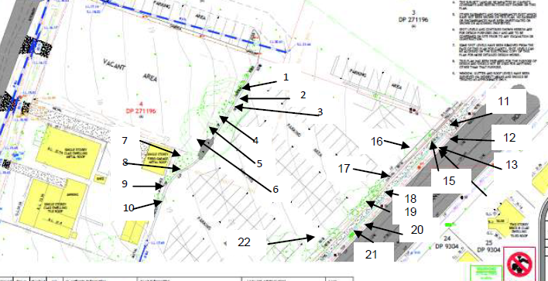
Above: Tree location plan for the northern part of the site from the arborist report

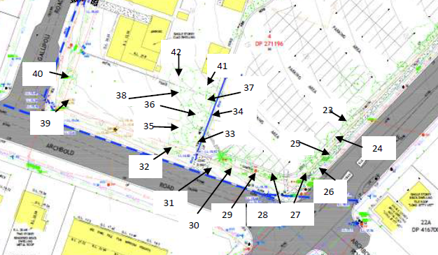
Above: Tree location plan for the northern part of the site from the arborist report

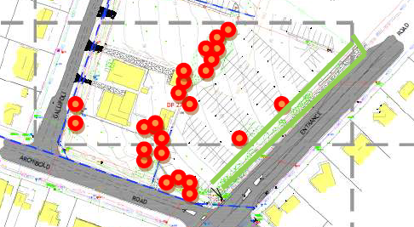
Above: Tree Management Plan with trees to be removed in red and the tree protection zone in green

- Safety, security, and crime prevention (CPTED Principles)

The principles for Crime Prevention Through Environmental Design (CPTED) have been considered under the design of the proposed new development. A CPTED assessment of the proposal has been provided. The proposal incorporates design features and passive security management measures to discourage anti-social behaviour and minimise the opportunities for criminal activities. This has been achieved using natural surveillance and access control measures that will be supported through space and activity management that occurs on the site.

Measures to be adopted on site include:

Territorial re-enforcement
- Adoption of suitable fencing to secure areas and restrict unauthorised access. A fencing plan has been provided for the development.
- Planting and managing landscaping vegetation to maintain surveillance/clear sightlines and to designate boundaries.
- Adoption of signage to assist in way finding and to signpost where access is prohibited or private.

Surveillance
- The design of the building and landscaping aims to maximise (not inhibit) natural surveillance and avoid any entrapment or concealment opportunities.
- Suitable lighting (AS1158) throughout common areas within the development.
- Deadlocks on all doors and windows.
- On site 24-hour manager with security monitoring during evenings.
- CCTV throughout the site.

Access Control
- Clear signposting of all entry points, and identification of private areas.
- Secure boundary fencing.
- Restrict general public access after-hours.
- Car park accessed via secure entry- access restricted to residents only by a keypad, swipe card or remote system.
- Pedestrian access into building via a single, well located and secure foyer clearly visible from the street.

Space/Activity Management
- Install “park smarter” signage in car park.
- Maintain common areas and rapid repair/replacement of any fixtures or common property.
- Provision of letter boxes in an enclosed/secure location in the foyer with a window visible from the street frontage.
- Provision of seating and other facilities in open, well-lit areas.
- Waste areas be secured.
- On site Manager be the single point of contact for trades people.

The recommendations in the CPTED report prepared for the development are to be adopted under recommended conditions.

- Air quality

A condition is recommended in relation to dust control during demolition, earthworks and construction requiring adoption of appropriate measures to minimise emissions into the surrounding environment. There is minimal potential for any air pollution, odour, fumes, or other air quality impacts associated with the development on the site.

- Noise and vibration

An acoustic assessment report was prepared for the proposal in relation to potential noise impacts associated with the proposal including:

• noise generated by mechanical plant on the proposed development,
• any traffic noise generated by the proposed development; and
• road traffic noise intrusion from The Entrance Road into the proposed development.

The assessment found that subject to the fitting of windows and sliding doors as per the requirements of the assessment, an acceptable internal acoustic amenity for various areas of occupancy in the building will be achieved to effectively mitigate any adverse noise impact from traffic on The Entrance Road.

This assessment was reviewed by Council’s Environmental Protection Officer who raised concerns and requested a further report be prepared which addressed the potential impacts of at least 15 vehicles and congregational noise coming from 60 persons (4 adult persons per vehicle) utilising the “Diggers” carpark until midnight. Included in this further acoustic assessment were the calculated workings that determines the “Distance Loss to Receivers” for vehicle and congregational patronage noise being generated from within 25 meters of the proposal and or to the closet residential receivers.

It is noted that the relocation of club car parking to (effectively) the opposite end of the site (under the recent consent for construction of the new carpark) will also redirect most of those movements away from the proposed development and their associated noise from the Archbold Road end of the site.

Council’s Senior Environmental Protection Officer has advised consideration has been given to the following acoustic reports and advice that was prepared on behalf of the applicant.

- Noise Impact Assessment by Spectrum Acoustics (D14840958)
- Additional Acoustic Information (D15236121)

Traffic Noise

Based on the performed calculations and the “Road Traffic Noise Criteria”, the units facing The Entrance Road would experience elevated noise without any attenuation measures. Given the multi storey level design, the only mechanism to attenuate any potential impacts would be through the construction materials used for these units, e.g., balustrades on the deck, Concrete/ Brick for walls/ceilings and floors and double glazing for any glass windows or doors.

A suitable condition is recommended that requires all recommended attenuation measures to be adequately applied to ensure that the internal use of each unit is not unreasonably impacted by any outdoor noise sources.

Noise from Car park

Further consideration and commitment by the applicant in the form of a “Plan of Management” and “Carparking Policy” has ensured that the concentrated use of Diggers is managed and controlled at the front of the facility and is away from the proposed senior living development. Diggers will provide resources to manage their patrons’ behavioural responsibilities whilst on the premises.

The new Carparking Policy has restricted parking away from the proposed senior living development and has dedicated car parking spaces for the Hotel and Club. To ensure that the patrons appropriately use the correct parking allocation, signage will be provided throughout the property.

To ensure the ongoing commitment to the “Plan of Management” and “Carparking Policy” is maintained, it is recommended that an ongoing conditional requirement be applied to ensure compliance to the approved “Plan of Management” and “Carparking Policy” is achieved.

The sampling data, methodology and findings of the amended acoustic assessment have been reviewed and Council’s Senior Environmental Protection Officer concurs with the recommendations and noise control measures specified in the acoustic report subject to recommended conditions.

- Overshadowing – internal and external to the site

External to site
Shadow diagrams have been prepared for the development for 9:00am, midday and 3:00pm, for 21 June (midwinter), in order to demonstrate a worst-case scenario for solar access on the shortest day of the year. Due to the orientation of the site, the shadowing created by the building extends away from the club site and towards each of the road frontages of the site.

In this regard, overshadowing created mid-winter by the proposed development will primarily occur across the front yards of properties opposite the site fronting The Entrance, Gallipoli and Archbold Roads and even then, the shadows will remain for periods of essentially only 3 hours per day between 9am and 3pm on 21st June. The private open space to the rear of these surrounding properties will continue to enjoy over 3 hours of solar access.

The townhouse development on the opposite (southern) side of Archbold Road (No. 335 The Entrance Road), has its open space as front courtyards facing Archbold Road. Although these courtyards are overshadowed during the morning period, they continue to obtain at least 3 hours of unobstructed sunlight late morning and into the afternoon which meets the requirements of the planning controls.

There are no unreasonable amenity impacts resulting from solar access loss to any existing surrounding residential development or public areas because of the development. The overall extent of shadowing impact resulting from the proposal to surrounding properties is considered reasonable.
Internal to the site

The mid-winter shadowing from the proposal does not reduce the solar access to any required private open space internally. The height and FSR for the proposal are compliant with Council’s planning controls and the overall solar access to each new apartment is more than the requirements, as 80% of all apartments achieve 3 hours solar access to their living areas and POS areas.

There are no unreasonable amenity impacts resulting from unsatisfactory solar access internal to the design as a consequence of the development. Overall, considering the site constraints and the desired increased density of development on the site under Council’s controls, the proposed development is considered satisfactory in terms of shadowing impacts.

- Impacts to views

Views of Tuggerah Lake and beyond are available from the site and from properties located on the eastern side of the highway. These views from the development opposite the site are afforded to these properties through and across the subject site and therefore will be interrupted by the development.

A view analysis was prepared by the applicant which considered the view sharing principles set out in the NSW Land and Environment Court Judgment Tenacity v Warringah [2004] having regard for:

1. Assessment of views that may be affected.
2. Consideration of what part of the property the views are obtained.
3. Assessment of the extent of the impact.
4. Assessment of the reasonableness of the proposal that is causing the impact.

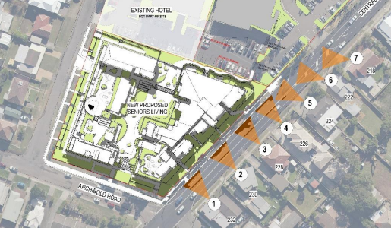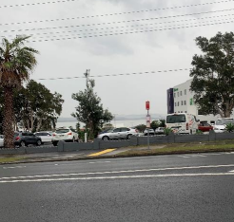
Above: Extract from the applicant’s view analysis of the affected site and one viewpoint

1.Assessment of views that may be affected.

The views are of water and are generally available from the properties opposite the proposed development on The Entrance Road. The views to the water are not whole views but are obscured in the interface between land and water by The Entrance Road; existing trees and vegetation on the edge of the existing carpark; the existing Diggers carpark and two dwellings on site; dwellings beyond the site.

2. Consideration of what part of the property the views are obtained.

The existing houses located opposite the proposed development are currently mainly one storey residential dwellings, one vet and one two storey townhouse that front The Entrance Road. The area is zoned R1: General Residential with a height limit of 9.5m. These existing buildings have partial and obscure views to the water which is located 300-360m away.

The buildings face the busy The Entrance Road, and the noise, privacy and western sun/ heat glare issues prevent comfortable amenity to the rooms facing the potential view corridors/ aspects. The only building that did not have blinds on the windows was the Vet located at 232 The Entrance Road which has views of the water significantly obscured by existing vegetation to the carpark. Their primary private open space is generally located behind the houses, away from the noise generated by The Entrance Road (Central Coast Highway). There is currently no view from these private outdoor areas or any windows without blinds to the water.

3. Assessment of the extent of the impact.

In assessing the extent of the impact of the proposal the guidance set out in Tenacity Consulting v Warringah was utilised:

The third step is to assess the extent of the impact. This should be done for the whole of the property, not just for the view that is affected. The impact on views from living areas is more significant than from bedrooms or service areas (though views from kitchens are highly valued because people spend so much time in them). The impact may be assessed quantitatively, but in many cases this can be meaningless. For example, it is unhelpful to say that the view loss is 20% if it includes one of the sails of the Opera House. It is usually more useful to assess the view loss qualitatively as negligible, minor, moderate, severe or devastating.

The view analysis concludes that the view loss is minimal as the current water view is obscured by existing vegetation and the car parkas, and the orientation of the view is across a busy main road. The closed blinds on a number of houses to block sun glare and noise indicate a likely lower level of sensitivity to changes to the view from residents. Their primary private open space is generally located behind the houses, away from the noise generated by The Entrance Road. There is currently no view from these private outdoor areas or any windows without blinds to the water.

4. Assessment of the reasonableness of the proposal that is causing the impact.

The current design generally complies with the planning controls, including height, setbacks, FSR, SEPP 65 and ADG requirements. The proposal sits within this envelope of site constraints. As the water views from the existing buildings are minimal and dominated by a busy road in the foreground which makes it difficult to provide any reasonable view amenity, the complying design should be considered acceptable and the view sharing reasonable.

The views to be affected are generally limited as they are obtained from the frontages of properties facing The Entrance Road which generally have small windows. The private outdoor areas for the properties in question are located to the rear, away from the noise and any potential water views.

It is acknowledged that the proposal complies with the planning controls related to the envelope of the development including height, FSR, setbacks and building separation – such that it would be unreasonable to require any adjustments to the design. The views are available through the site given Lot 3 has not been developed to date, but largely contains an at grade car park and some dwellings.

- Privacy

Overlooking potential has been minimised in the design of the development by providing compliant setbacks, sensitive placement of open space, screen planting around the boundaries and the inclusion of design measures such as louvres and sunscreens and the location, orientation and type of windows (e.g., highlight, hopper or clerestory) and some privacy screens to balconies. The proposal also includes comprehensive landscaping of the site (particularly within setbacks).

Additionally, the significant physical distance and separation will minimise potential visual privacy issues by virtue of the site having three street frontages and no adjoining shared residential boundaries. This means that the proposed development will face towards the front yards of dwellings on the opposite sides of each of the three roads fronting the site.

- Social impact

Social Impact Assessment

A Social Impact Assessment (SIA) has been prepared for the proposed development which has addressed the potential social benefits and impacts to the existing and future local community. The report identifies the demographic of the area being comparatively older age profile than the NSW average (with higher proportions of resident aged 65 and older and widowed, divorced or separate people). The report also identifies the increased life expectancy for older Australians and the increased demand for apartment-based housing stock such as the proposed development, (which implies efficient use of available land) and the progressive shift for residents aged 55 years and older towards medium and higher density dwellings where maintenance demands are lower.

The SIA included community consultation in the form of a mail-out (in May/June 2021) to 59 surrounding properties and 3 responses were received. The matters raised in the responses are addressed under the SIA and include traffic impacts; property values; construction of road and pedestrian infrastructure; parking provision for residents/visitors and club patrons; construction noise and operating hours; access during construction; general noise impacts; building too large.

The SIA outlines the locational advantages of the site (to public transport, community /social /recreational facilities and activities, medical/health infrastructure and retail/ commercial services and emergency services.

The SIA also outlines recommendations and mitigation measures under section 9.2. The SIA concludes that the proposed development will provide a modest increase in relatively affordable residential accommodation for the fastest-growing age groups in the area. The development is consistent with certain regional policy aims in terms of population and housing management.

Operational and Other Management Plans

The operation of the club on Lot 4 is governed by an adopted Plan of Management (POM) titled Diggers @ the entrance - Plan of Management – Operation, Security, Alcohol, car parking and Housing Policy. The POM establishes the management criteria for the club premises. It includes measures to ensure the safety, security, and amenity of the surrounding residential areas.

A management statement for the strata scheme accompanied the proposal identifying the by-laws, rights, responsibilities, and obligations that apply to future residents. There is also a draft updated Community Management Statement (CMS) applying to the operation of Lot 4 as a “seniors living residential accommodation” (instead of simply a future use) under Clause 4.8(d).

The CMS is updated from the earlier Community Title Subdivision of the broader parent lot encompassing Lots 1-4 that include the club (Lot 3), the hotel (Lot 2), electricity kiosk (Lot 1) and the subject site (Lot 4). The CMS also provides further clarification or details of the connections to the Club. The CMS will be finalised following completion of the development and registered as part of the new strata plan.

In addressing potential conflict between land uses, the Club is bound by the Responsible Service of Alcohol (RSA) and Responsible Conduct of Gambling (RCG) laws regulated by NSW Liquor and Gaming which, by reference to residents becoming members of the Club in the CMS, by default ties the residents to these requirements and the minimisation measures therein. Other protocols and measures to manage these aspects of the Club and any potential conflict or adverse impact on future residents are identified in the SIA.

Additionally, a draft Operations Agreement is being prepared for the use of Lot 4 by the development’s residents and outlines the terms of the relationship between the club and the future residents. It will identify what club services are available to the residents and includes details associated with club entry and membership, access to food and beverages, access to the gym, access to parking, indemnity and insurance, and the legal relationship between the parties.

- Economic impact

The proposal will result in employment opportunities during construction and operation with potential multiplier effects into other services due to an increase in demand. The SIA notes that the relevant economic and employment effects may have particularly localised benefit in the ongoing maintenance, repair and related works required in respect of individual dwellings in the development, and maintenance of common property and assets across the development site.

Accordingly, it is considered that the proposal will not result in any significant or unreasonable adverse impacts in the locality as outlined above.

  - Section 4.15(1)(c) - Suitability of the site

The site is in a suitable context for the nature and type of development proposed being centrally located on a well serviced relatively unconstrained site. The site will offer future residents a high level of residential amenity with both retail and recreational opportunities within proximity of the site.

There are no significant site constraints or hazards that would render the location of the development as unsuitable. The building form will present well within streetscape and will not adversely impact on the character and amenity of the locality.
The design of the proposed development is in an appropriate form, layout and scale that suitably balances the opportunities and constraints of the site. Subject to recommended conditions the proposal will not adversely impact on the amenity of surrounding residential activities within the locality. The architectural design and treatment of the building will present well on all facades. There are no other matters relating to site suitability that require further consideration or discussion.

  - Section 4.15(1)(d) - Public Submissions

The proposal was notified in accordance with Wyong Development Control Plan 2013, Chapter 1.2-Notification of Development Proposals, with no submissions being received as outlined in Section 5 of this report.

  - Section 4.15(1)(e) - Public interest

The proposal will provide additional housing opportunities for seniors in an established and well serviced area with a high level of residential amenity. The location and form of the housing is not inconsistent with the Central Coast Regional Plan 2036 (which tends to focus more on the regional growth corridor west of the lake).

The provision of seniors housing is in the public interest as it provides an important form of community infrastructure that supports community well-being and social inclusion for older residents. The site is readily accessible to public transport, shops and services and is next door to an existing registered club. The proposal will increase the available stock of seniors housing in Long Jetty.

There are no matters associated with the proposal that are contrary to the local or community interest.

- REFERRALS AND SUBMISSIONS
  - Agency Referrals and Concurrence

The development application has been referred to the following agencies for comment/concurrence/referral as required by the EP&A Act and outlined below in Table 4.
There are no outstanding issues arising from these concurrence and referral requirements subject to the imposition of the recommended conditions of consent being imposed.
Table 4: Concurrence and Referrals to agencies
Agency | Concurrence/  referral trigger | Comments  (Issue, resolution, conditions) | Resolved
Concurrence Requirements (s4.13 of EP&A Act)
N/A
Referral/Consultation Agencies
Transport for NSW | The proposed development will have direct pedestrian access to The Entrance Road, a classified State road. The proposed new premises is of a size and capacity listed in schedule 3, column 3 of the TISEPP, and is therefore a traffic generating development from an active transport perspective. TfNSW recommends that consideration be given to measures to enhance safety and accessibility for pedestrians and cyclists. | Comments have been provided and these have been addressed under the assessment information and addressed under recommended conditions. | Y
Integrated Development (S 4.46 of the EP&A Act)
N/A

  - Council Referrals

The development application has been referred to various Council officers for technical review as outlined Table 5.

Table 5: Consideration of Council Referrals
Officer | Comments | Resolved
Development Engineer | No objection subject to recommended conditions | Y
Traffic Engineer | No objection subject to recommended conditions | Y
Water & Sewer Engineering | No objection subject to recommended conditions | Y
Environmental Protection | No objection subject to recommended conditions | Y
Waste Officer | No objection subject to recommended conditions | Y
Tree Officer | No objection subject to recommended conditions | Y
Architect/Urban Designer | No objection subject to recommended conditions | Y
Contributions | No objection subject to recommended conditions | Y

  - Community Consultation

The proposal was notified in accordance with the Council’s Wyong DCP Chapter 1.2 (Notification of Development Proposals) from 1 October 2021 until 1 November 2021. There have been no submissions received. The amended plans did not include any changes that warranted the renotification of the proposal in accordance with Clause 2.10c (Notification of Proposals Amended Prior to Determination).

- KEY ISSUES

The following key issues are relevant to the assessment of this application having considered the relevant planning controls and the proposal in detail:

Issue | Applicant’s response and discussion | Resolved
SEPP 65 and ADG requirements including compliance issues – solar access and building orientation, separation and privacy, overshadowing, communal and private open space dimensions, engineering, noting that the  density is creating amenity issues (acoustic and visual privacy) | The applicant initially advised There are no set distance objectives regarding separation between apartments in the same building, only between buildings. This area of the SEPP is intended for building separation, rather than apartment separation.  However, following further discussions, amended plans were provided which addressed all the issues that were raised including increased solar access, communal open space and separation of units for visual privacy. | Y
Applicant disagrees that SEPP 65 applies to the development | Legal advice has been received from Pickup Legal addressing the issue of SEPP 65 and it’s applicability to the proposed seniors housing development. The advice concludes that “as the DA is not development to which clause 4(1) of SEPP 65 is caught, I do not consider that the provisions of SEPP 65 apply to the development”. It also further concludes that “the provisions of the Seniors SEPP are not relevant and its provisions do not need to be  applied”  Separate legal advice was obtained by Council refuting this position. Nonetheless, the proposal has been amended to comply with the provisions of SEPP 65 (and the ADG) and the proposal is considered satisfactory. | Y
Legibility and wayfinding for the building in the north-western corner. Wayfinding, building access points and location of lift cores/building separation identification | The amended plans show a clear and identifiable street address with entry structure here. An entry structure has also been added to the office and meeting space on the south to give it a greater sense of address. Updated plans are attached showing a clear and identifiable street address as well as a wayfinding plan on RFI102. | Y
Acceptability of the interface with the adjoining car park | Plans have been amended to provide a greater setback area to enhance residential amenity for apartments positioned along this boundary. A new fence type has also been proposed for this boundary that maximised privacy and natural light while minimising headlight glare - refer to RFI113. An update of the pedestrian link area is provided on A107. Updated Edge Interface Sections have been provided on RFI 16. An updated landscape plan for this area has also been provided. Refer to Attachment No 7. Landscape Drawings  Amended plans were provided to further step the retaining walls.
Provision of bicycle parking | Sufficiently sized storage areas have been provided within the basement level for each unit which can accommodate bicycle or motor scooter parking. | Y
Noise assessment to be reviewed to consider location of car park and roller door near bedrooms and ability to leave windows open whilst maintaining noise compliance | Units 1 and 3 have solid masonry fencing to the vehicle entry, the windows facing inwards have been removed, refer to the updated acoustic report for noise mitigation from trucks and the adjacent club carpark.  The Acoustic report was amended and the proposal is satisfactory subject to recommended conditions. | Y
Engineering related matters (stormwater, roads, sewer servicing) | Plans have been changed to comply with verge formations and footpaths.  The traffic engineer has provided intersection sight distances which show that the safety clearances occur outside of the site boundary in the council verge. The OSD system designed to limit run-off to the capacity of this drainage system. Preliminary sewer diversion plans provided.  Addressed under amended plans and satisfactory subject to recommended conditions. | Y
Assessment with SEPP (Housing) needed | Not provided as the application was not lodged under SEPP Seniors Housing and is not affected by the subsequent replacement instrument for SEPP Seniors Housing – SEPP (Housing) 2021. Additionally, the General Savings provisions would apply. | Y
Waste services – location, access on site and adequacy for development | Manoeuvring addressed under amended plans and arrangement that does not include a waste chute is considered satisfactory subject to recommended conditions. The applicant advised:  Waste rooms and areas have been updated on RFI113.  The waste vehicle has been changed to an 11m HRV truck. An update has been provided on RFI114 showing bin sizes and fully dimensioned details.  Refer to attachment No9 Updated Waste Management Plan.  Travel path for the furthest unit is 37.5m (Unit 18). All areas in the carpark are free of steps or obstructions. The FOGO bins will be picked up from the waste area rather than a kerbside location.  Having waste chutes on each level can lead to odours that are undesirable, so we chose the option of placing the waste areas in the utilitarian space of the carpark, close to each lift core. These areas are easily cleaned and are easy for residents to access. It also means there is no need for bins to go into lifts which is often necessary for recycling bins, which can also cause odour issues in the lifts. Each waste area is placed close to the lift core of the block it corresponds to and restricts the odours to this area. Waste pick up services if required is available to residents on request as part of Body Corp management. | Y
Social impact and management of the Club (hours, patron behaviour) and noise management for the proposed residential development | Matters dealing with management of the Club are dealt with in the following documents provided with the initial DA  documentation:  • Draft Community Management Statement  • Operations Agreement  • Draft Management Statement – Yungala Seniors Village | Y
Pedestrian link to club | An all-weather covered walkway connecting the club and the development is considered an important element as a physical link as well as reinforcing the social relationship between the two entities. A suitable and safe design allowing vehicular and pedestrian traffic is provided on the updated pedestrian link plan A107  The traffic consultant has confirmed that 1.2m is required for the width of a path to allow mobility scooters to pass. The width of the proposed path is 1.5m so it should be wide enough for scooters to pass comfortably. | Y
Light spill from car park into below ground level units | A detail of new Fence Type 1 is provided on RFI113, this shows how the fence acts as a backstop to dissipate any headlight glare that is not stopped by planting. | Y
Confirmation of compliance with access requirements to bus stops located within 400m of site | RFI117 shows an accessible path to a bus stop on each side of the road. This is based on survey levels apart from the last 11m on the path to the South across the Central Coast Highway, to determine slope here 2m contour were used from Mecone Mosaic Mapping application. All gradients to the bus stop are less than the required 1/14. | Y
Additional design details required to adequately address solar access (including balcony  balustrading/screening) | Additional details provided including several solar study videos using a 3D flythrough model and amended plans and tables. | Y
Clarification regarding Gabion Floating Roof | The gabion floating roof is one layer of rocks suspended between two steel meshes and allows sunlight through (refer images below), although with less density.  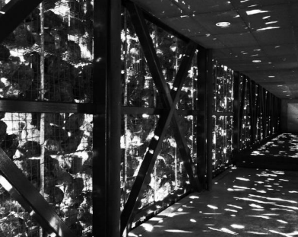 | Y
Groundwater likely to be encountered around the north-eastern corner of the basement, with sub-soil drainage connected to an absorption  system on-site proposed, noting overflow is to be connected to the stormwater system for large fluctuation events. | These marginal exceedances of ecological groundwater criteria were not considered to pose an unacceptable risk to human health or environment in its current state and do not require remediation/management. The justification for this is detailed in Section 11.2 of the DSI - refer to the attached response from the site contamination specialist. | Y
Construction of replacement parking to compensate for the loss of the existing club car park resulting under this development. | Consent No. DA/1196/2021 was granted on 21 July 2022 for the construction of a 2 level car park in the north eastern corner of Lot 3 to service the club. This consent will compensate for the removal of parking spaces for the current DA by creating 107 parking spaces. The development of Lot 4 for the proposed seniors housing development will result in the loss of 102 existing parking spaces. With the removal of a bowling green for the 2 storey carpark, the proposal will result in an increase of 13 spaces on site for the club. | Y

- CONCLUSION

This development application has been considered in accordance with the requirements of the EP&A Act and the Regulations as outlined in this report. Following a thorough assessment of the relevant planning controls, issues raised in state government authority submissions and the key issues identified in this report, it is considered that the application can be supported.

The proposed development directly addresses the housing needs in respect of the ageing population. As there is a disproportionately large representation of older single or lone person households in the area, the predominantly 2 bedroom apartment development as proposed is considered suitable for the site context.
The design and layout of the proposal is generally consistent with the relevant planning controls including SEPP 65 and the ADG, SEPP (Basix), Wyong LEP 2013 and Wyong DCP 2013. Some minor variations are proposed to the planning controls under WDCP and the ADG however these are reasonable within the scale, type and site context of the development proposed.

Furthermore, the proposed development is consistent with the provisions of Central Coast Local Environmental Plan 2022 and Central Coast Development Control Plan 2022 notwithstanding the application is subject to savings provisions. The proposed development is considered compatible with the locality and is recommended for approval subject to conditions.
It is considered that the key issues as outlined in Section 6 have been resolved satisfactorily through amendments to the proposal and/or in the recommended draft conditions at Attachment A.

- RECOMMENDATION

That the Development Application DA/1260/2021 for Senior Housing Development comprising 89 dwellings, in two buildings, strata subdivision and associated demolition, landscaping and other works at 24-26 Gallipoli Road and 315 The Entrance Road Long Jetty be APPROVED pursuant to Section 4.16(1)(a) of the Environmental Planning and Assessment Act 1979 subject to the draft conditions of consent attached to this report at Attachment A.

- ATTACHMENTS

- Attachment A - Draft Conditions
- Attachment B - ADG Compliance Table
- Attachment C - WLEP and DCP Planning Controls Compliance Table
- Attachment D - SEPP (Housing for Seniors and People with a Disability) 2004 Compliance Table
- Attachment E - Coastal Management Assessment under SEPP (Resilience and Hazards) 2021
- Attachment F - Architectural Plans

